**SG7011 – MBA Applied Business Analytics Project**

**Student Number:2644211**

**MARKING SCHEME FOR BUSINESS OR MANAGEMENT REPORT SUBMISSION**

|  |  |  |  |
| --- | --- | --- | --- |
| **Criteria** | **Comments** | **Weight** | **Actual Mark** |
| ***INTRODUCTION or TERMS OF REFERENCE:***  Some industry insights in the form of background commentary, the objectives for your chosen business |  | 15% |  |
| **PROCEDURE OR RESEARCH METHOD**  Students should explain the type of data from the simulation project that will be used in the report and why. |  | 10% |  |
| **FINDINGS AND DISCUSSIONS**  Evidence of rigor in data analysis and interpretation procedures, identification of key patterns and themes in the project data, integration of business theories (SWOT, PESTEL, etc) into explanation of findings.  It should follow a logical and systematic organisation and outlines all the rounds/years of operations |  | 50% |  |
| **CONCLUSION AND RECOMMENDATIONS**  Research question and objectives addressed with implications to theoretical and managerial concepts considered. Recommendations provided for theory, practice and future research |  | 15% |  |
| **ORGANISATION, PRESENTATION AND REFERENCES**  Well-structured and ordered project with correct use of grammar and syntax. In-text citation and bibliography conforming to “**Cite Them Right**”  *.* |  | 10% |  |
| **General Comments:** | | **Mark:** | |

Agreed Mark…………………………………………………………………

First Marker Signature………………………………………………… Date

Second Marker Signature…………………………………………… ...Date

**[Solex Management Simulation Project January 2025]**

A dissertation/management report submitted in partial fulfilment of the requirements of the Royal Docks School of Business and Law, University of East London for the degree of **[Management Report/Dissertation]**

**[Jan 2025]**

**[9000]**

I declare that no material contained in the thesis has been used in any other submission for an academic award

Student Number: Yuvraj Chauhan Date: 03/01/2025

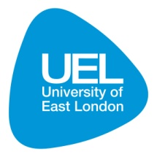

**Dissertation Deposit Agreement**

***Libraries and Learning Services at UEL is compiling a collection of dissertations identified by academic staff as being of high quality. These dissertations will be included on ROAR the UEL Institutional Repository as examples for other students following the same courses in the future, and as a showcase of the best student work produced at UEL.***

***This Agreement details the permission we seek from you as the author to make your dissertation available. It allows UEL to add it to ROAR and make it available to others. You can choose whether you only want the dissertation seen by other students and staff at UEL (“Closed Access”) or by everyone worldwide (“Open Access”).***

I DECLARE AS FOLLOWS:

* That I am the author and owner of the copyright in the Work and grant the University of East London a licence to make available the Work in digitised format through the Institutional Repository for the purposes of non-commercial research, private study, criticism, review and news reporting, illustration for teaching, and/or other educational purposes in electronic or print form
* That if my dissertation does include any substantial subsidiary material owned by third-party copyright holders, I have sought and obtained permission to include it in any version of my Work available in digital format via a stand-alone device or a communications network and that this permission encompasses the rights that I have granted to the University of East London.
* That I grant a non-exclusive licence to the University of East London and the user of the Work through this agreement. I retain all rights in the Work including my moral right to be identified as the author.
* That I agree for a relevant academic to nominate my Work for adding to ROAR if it meets their criteria for inclusion, but understand that only a few dissertations are selected.
* That if the repository administrators encounter problems with any digital file I supply, the administrators may change the format of the file. I also agree that the Institutional Repository administrators may, without changing content, migrate the Work to any medium or format for the purpose of future preservation and accessibility.
* That I have exercised reasonable care to ensure that the Work is original, and does not to the best of my knowledge break any UK law, infringe any third party's copyright or other Intellectual Property Right, or contain any confidential material.
* That I understand that the University of East London does not have any obligation to take legal action on behalf of myself, or other rights holders, in the event of infringement of intellectual property rights, breach of contract or of any other right, in the Work.

I FURTHER DECLARE:

* That I can choose to declare my Work “Open Access”, available to anyone worldwide using ROAR without barriers and that files will also be available to automated agents, and may be searched and copied by text mining and plagiarism detection software.
* That if I do not choose the Open Access option, the Work will only be available for use by accredited UEL staff and students for a limited period of time.

**/cont**

**Dissertation Details**

|  |  |
| --- | --- |
| **Field Name** | **Details to complete** |
| Title of thesis/project  *Full title, including any subtitle* | Solex Management Simulation Project January 2025 |
| Supervisor(s)/advisor  *Separate the surname (family name) from the forenames, given names or initials with a comma, e.g. Smith, Andrew J.* | Chauhan, Yuvraj |
| Author Affiliation  *Name of school where you were based* | Royal Docks School of Business and Law, University of East London |
| Qualification name  *E.g. MA, MSc, MRes, PGDip* | MBA |
| Course Title  *The title of the course e.g.* | MBA (Business Analytics) |
| Date of Dissertation/Management Report  *Date submitted in format: YYYY-MM* | 03/01/2025 |
| Does your dissertation contain primary research data? (If the answer to this question is yes, please make sure to include your Research Ethics application as an appendices to your dissertation) | Yes No |
| *Do you want to make the dissertation Open Access (on the public web) or Closed Access (for UEL users only)?* | Open Closed |

**By returning this form electronically from a recognised UEL email address or UEL network system, I grant UEL the deposit agreement detailed above. I understand inclusion on and removal from ROAR is at UEL’s discretion.**

Student Number: 2644211 Date: 03/01/2025

# EXECUTIVE SUMMARY

The specific objective of the Solex Management Simulation Project entailed effective management of a sneaker company in the highly competitive market through enhancing profitability, solvency, and product quality. It included the issues of pricing, advertising, and operational changes to achieve the net profit of €500 000 – €2 500 000, solvency ratio of at least 50% and high quality of the offered products. Despite solvency and incremental revenues, only moderate degrees of success were realized in satisfying profitability targets and product quality, and these figures demonstrate that more effective strategies were required.

Primary research findings showed the need to involve customers, supply chain integration, and digital marketing in an organization’s affairs. Business analysis tools such as a SWOT initiative and Ansoff’s Growth Matrix offered strategic planning guidance; and integration and response mechanisms formed the basis of market strategy.

The project identified other relevant issues such as matching organizational strategy while outlining needs in the area of innovation and pressures emanating from competition. While the existence of shortfalls in some of these objectives cannot be disputed, it served as a useful reference on how to run the businesses in competitive markets.

**Table of Contents**

EXECUTIVE SUMMARY 2

CHAPTER 1: INTRODUCTION 5

1.1 Background 5

1.1.1 Project Focus 5

1.1.2 Industry Insights 5

1.1.3 Company Overview 5

1.1.4 How the Business Name Was Chosen 6

1.1.5 Objectives and Team Roles 6

1.1.6 Difficulties Encountered During the course of the Process 7

1.1.7 Company Logo 7

1.1.8 Report Structure Overview 8

CHAPTER 2: METHODOLOGY 10

2.0 Introduction 10

2.1 Re-establishment of Business Purposes and Field 10

2.2 Data Involved in the Study 11

Rationale for Data Selection 12

2.3 Analysis and Interpretation of Data 12

2.4 Limitations 13

2.5 Conclusion 13

CHAPTER 3: FINDINGS AND ANALYSIS 14

3.0 Introduction 14

3.1 Year 1: Establishing Market Presence 14

Decisions Made: 14

Outcomes 16

Lessons Learned 16

3.2 Year 2: Enhancing Customer Engagement 17

Decisions Made 17

Outcomes: 18

Lessons Learned: 20

3.3 Year 3: Leveraging Market Penetration Strategy 20

Decisions Made: 20

Outcomes: 21

Lessons Learned: 21

3.4 Year 4 - Managing Inventory Effectively 22

Decisions Made 22

Outcomes 25

Lessons Learned 26

3.5- Year 5- Sneakers Market Analysis 26

Decisions Made 26

Outcomes 27

Lessons Learned 28

3.6- Year 6- Consumer Preferences for Men's and Women's Sneakers" 29

Decisions Made 29

Outcomes 31

Lessons Learned 32

3.7- Year 7- price Development in the Solex Simulation 33

Decisions Made 33

Outcomes 34

Lessons Learned 35

3.8 Year 8- Evaluating Final Performance 36

Decisions Made 36

Outcomes 37

Lessons Learned 39

3.9 Conclusion 40

CHAPTER 4: CONCLUSIONS 41

4.1 Realisation of Business Aims 42

4.2 Theoretical Implications 42

4.3 Managerial Implications 42

4.4 Meeting original goals 42

4.5 Final Thoughts 43

CHAPTER 5: THE RECOMMENDATIONS 43

5.1 Implications for Management Practice 43

5.2 Recommendations for Wider Society 44

5.3 Recommendations for Future Simulation Projects 44

5.4 Reflection on Findings 44

5.6 Conclusion 45

References 46

**Table of Figure**

Figure 1: Company Logo 14

Figure 2: Products Price 21

Figure 3: Market 2024- Men Sneakers 22

Figure 4: Market 2024- Women’s Sneakers 22

Figure 5: Market 2024- Kid’s Sneakers 23

Figure 6: Balance Sheet -2024 24

Figure 7: Inventory 2024 25

Figure 8-: Staff Comparison over years 26

Figure 9: Market 2025- Men Sneakers 27

Figure 10-: Market 2025- Women’s Sneakers 28

Figure 11-: Market 2025- Kid’s Sneakers 28

Figure 12: balance Sheet 2025 30

Figure 13: Inventory 2025 31

Figure 14: Market 2026- Men Sneakers 33

Figure 15: Market 2026- Women’s Sneakers 34

Figure 16: Market 2026- Women’s Sneakers 34

Figure 17: Balance Sheet -2026 35

Figure 18: Inventory 2026 36

Figure 19: Market 2027- Men Sneakers 38

Figure 20: Market 2027- Women’s Sneakers 38

Figure 21: Balance Sheet 2027 39

Figure 22: Inventory 2027 40

Figure 23: Distributor of Men’s Sneaker 41

Figure 24: Distributor of Women’s Sneaker 42

Figure 25: Distributor of kid’s Sneaker 43

Figure 26: Market of Men’s sneakers- 2028 46

Figure 27: Market of Women’s sneakers- 2028 46

Figure 28: Market of Kid’s sneakers- 2028 47

Figure 29: Balance Sheet- 2028 48

Figure 30: Inventory- 2028 48

Figure 31: Market of Men’s sneakers- 2029 50

Figure 32: Market of Women’s sneakers- 2029 51

Figure 33: Market of Kid’s sneakers- 2029 51

Figure 34: Balance Sheet- 2029 52

Figure 35: Inventory- 2029 52

Figure 36: Men’s Product Line 53

Figure 37: Women’s Product Line 54

Figure 38: Men’s Sneakers Market- 2030 55

Figure 39: Women’s Sneakers Market- 2030 56

56

Figure 40: Kid’s Sneakers Market- 2030 56

Figure 41: Balance Sheet- 2030 57

Figure 42: Inventory- 2030 57

Figure 43: Men’s Sneakers Market- 2031 59

Figure 44: Women’s Sneakers Market- 2031 60

Figure 45: Women’s Sneakers Market- 2031 60

Figure 46: Balance Sheet- 2031 61

Figure 47: Inventory - 2031 62

Figure 48: Overall Ranking of Solex 63

Figure 49: Net Profit Over years 63

Figure 50: Net Quality Over Years 64

# CHAPTER 1: INTRODUCTION

The Solex Management Simulation Project was fun and interactive way of learning about managing a company in the realistic sneaker market environment. This chapter lays down background to the report by presenting the subject of the work, giving an industry overview, a background of the firm, and the issues faced in the project. It also describes the roles of the team members and offers the outline of the report.

## **Background**

The Sneakers Incorporated Business Simulation entailed forming many groups of students who were assigned the responsibility of managing a sneaker firm known as Sneakers Incorporated. This company, which specialises in affordable and moderately-wearing shoes for men and women, became a brand that offered all users something. However, during an economic crisis, the company faced some problems with sales and its very existence, as consumers changed their preferences and the business was sold. It was from this simulation that the students began to direct Sneakers Incorporated and everything and everyone associated with it. The project included eight rounds for each of the participating business years during which the players were supposed to make strategic moves to run a sneaker business. The key development within the scope of the project was management efficiency, the achievement of organizational and tactical goals, which were pursued by the organization in a competitive environment to provide profit, increase the share in the market, and ensure the further development of activities (Edumundo 2024).

### **1.1.1 Project Focus**

The main purpose of the Solex Management Simulation Project was to exercise management of sneaker company, Solex, in a dynamic environment and a competitive market. The simulation includes competition, planning, decision making with a view of making a certain amount of profit within specified period thus had some small goals such as profitability, sustainability and the ability to penetrate into the market (Edumundo 2024).

### **1.1.2 Industry Insights**

Global sneaker industry is mostly competitive due to higher rate of innovation, changing consumer trends and the increasing consideration of sustainability practices in the sneaker industry. The customer demand has grown due to social factors like popularity of athleisure products and the novel use of e-commerce. Businesses are today forced to produce affordable, good quality, and sustainable products to satisfy different customers (Voigt, 2016). There are certain tendencies that can be highlighted, such as the focus on the sustainable use of materials, product individualization, and the application of digital approaches to reach the buyers.

### **1.1.3 Company Overview**

Solex is an imaginary company of sneakers used during the simulation. The business motto of the company is ‘Create Your Own Story with Your Footstep,’ that the company has towards its customer of providing quality, fashionable, and environmentally friendly shoes. The logo of the company captures the entire brand personality of the company that is innovation and sustainability (Hinton, 2023).

Mission: To provide the best quality, fashionable and qualitative shoes and satisfaction of different type of customers.

Vision: Innovate and deliver sustainable products, focusing on customer satisfaction in a bid to become the go-to brand in the global sneaker market.

### **1.1.4 How the Business Name Was Chosen**

The name “Solex” was coined to portray the fact that the new company will mainly deal in footwear and the desire for excellence as portrayed by the letter ‘ex’ in the name. The name is basic, easy to recall and corresponds with the mission statement of building a distinctive and meaningful brand within sneaker segment (Edumundo 2024).

### **1.1.5 Objectives and Team Roles**

Solex aimed to achieve the following key objectives during the simulation:

* Realize a negative operating margin but a positive net profit, and to obtain a net profit between 500 000 € and 2 500 000 €.
* Purposely ensure that the solvency ratio is not below 50%.
* It requires reaching an average set of quality metrics within the range of the 3rd to the 5th result among rivals in the product’s relevant quality segments (Voigt, 2016).
* Maintain high level of staff motivation in order to achieve high level of performance.

**The team consisted of four members, each assuming a critical role:**

* Chief Executive Officer (CEO): This individual is the head of the overall tactic, the core organizer, the project’s leader of the team.
* Finance Manager: Control and monitoring of departmental expenses, preparation of the departmental operational budgets, preparation of cash and share working capital budget statement, submission of loan proposals to the banking department.
* Logistics Manager: Supervised delivery chain logistics and stock control processes too.
* Marketing Manager: Under the domain of promotions and publicity, I performed and coordinated/search engine optimization efforts and launch of social media campaigns (Savic, and Gugyela, 2023).

### **1.1.6 Difficulties Encountered During the course of the Process**

Throughout the simulation, the team encountered several challenges, including:

* Easy ways to achieve the price that is convenient for everyone to afford but at the same time considering the quality of the product to create an extra value to appeal to different demographic groups.
* Managing supply chain related disruptions and varying cost volatility of raw materials.
* This has been done with a view to dealing with high intensity competition from Industry giants (Hinton, 2023).
* Intensifying marketing to reach as many customers as possible per time on behalf of the brand.
* These were some of the hardships that the company faced and to solve them demanded creativity, flexibility and effective cooperation among the members of a team.

### **1.1.7 Company Logo**



**Figure 1: Company Logo**

*(Source: Edumundo, 2024)*

The logo of the Solex company is colourful and wards-based which corresponds to the sneaker brand and the active youth subculture. Following are the elements of the logo-

**Visual Elements**: A pair of artfully designed colourful sneaker is featured large and clear in the middle of the logo. They are yellow, purple, blue and white, and it gives a rather fresh and active look, which will necessarily attract attention. The design of the sneakers adds creativeness to the logo (Voigt, 2016).

**Typograph**y: The name of the company is SOLEX written in capital letters that are clear identified and look modern which bring idea of professionalism. The text colour is white while the background colour is black hence the visibility and the appearance are classy.

**Tagline:** Under the brand name there is a slogan “Create your own story with your footstep!” This phrase is truly inspiring and has aspects of individualism and service with an adorning appeal to consumers who want to be special and feel special (Savic, and Gugyela, 2023).

**Overall Design**: The logo has chosen black background colour because all the other elements – sneakers and the type – are bright and cheerful in comparison and this design works perfectly. A strong hard-style vision and an appealing call to action underlines the spirit of the brand targeting a lifestyle aspect.

### **1.1.8 Report Structure Overview**

This report is organized into five concise chapters providing insights into the Solex Management Simulation Project:

**Chapter 1: Introduction**

In the first chapter of the Solex Simulation Game report, the readers are expected to learn about the focus of the project; the goals of the project; and the contribution of the team in the business simulation game. It shows the background of the chosen business, typify industry information and commentaries, and describes the process of choosing the business name for the venture. Multiple aspects of the program are analysed in the chapter, including the company’s mission and vision, and the goals for the team that was set before or during the simulation. Also, it steps further to the kind of difficulties experienced throughout the process and flattering that includes the whole team and also breaking down the job description of each member in the group. The chapter ends with an understanding of the structure of the report and how it is developed to enable readers to navigate around the report, and grasp the areas of importance in the subsequent chapters.

**Chapter 2: Methods**

The Methodology chapter describes the aims and goals of the study, sources of data, and methods used during the course of the project. The specific business objectives comprised of €500, 000 to €2,500, 000 in profit, 50% solvency ratio and highly standard products. Such information as sales history, balance sheets, marketing metrics, and inventory data were used. The frameworks that were used in analysis include the SWOT analysis and Ansoff’s Matrix, supplemented by trend analysis from the data visualization tools (Pereira, 2019). However, there were several limitations that are as follows: the time constraint and the fact that data was collected under simulated contexts that imposed certain constraints on strategy implementation.

**Chapter 3: Findings and Discussion**

This chapter focuses on the simulation results and accumulated knowledge throughout eight years of operation. In the first year, strategies involved getting into the market with competitive prices, then, in the second year of operation, there was the need to improve the organization’s online marketing strategies. In the 3rd and 4th year strategies focused on product differentiation and improving supply chain management in the 5th year expanded a customer retention initiative offered in the form of a loyalty program. Downloading of sustainability files and proper promotions helped to strengthen Solex’s market base from Years 6 to 8. According to the SWOT analysis, important strengths were brand recognition and innovative marketing whereas weaknesses were touching high production costs. Others such as the opportunities of e-commerce growth and a threat of intense competition were also pointed out. Financial trends showed continuously improving results; net profit goals being met by Year 6 of implementation; and solvency and quality ratios has been maintained at appropriate levels.

**Chapter 4: Conclusions**

The conclusions therefore reiterate the importance of information processing in decision-making and flexibility in business. Marketing activities, supply chain, and customer-oriented efforts were identified as key strategic approaches that were useful to achieve the goals by Solex. With regard to emerging trends, the project demonstrated that collaboration and communication were key factors in dealing with such factors and managing organisational performance.

**Chapter 5: Recommendations**

Recommendations here centre on maintaining Solex’s competitive advantage and picking better simulations in future. In its case, Solex’s strategy is recommended to focus on innovation investment to enhance and increase the extent of digital marketing. In future simulation projects, the duration as well as the cases have to be selected in such a manner that they are as close to real-life situations as possible. Furthermore, the specification of sustainability and community involvement in the long-term plans can yield various anticipated values for the broad population as well as fit the shifting customers’ expectations. In the final part, this report provides the reader with the extensive look at the case and valuable perspectives at how to manage the business in the competing market with more focused discussions across these chapters.

# CHAPTER 2: METHODOLOGY

## **2.0 Introduction**

This chapter discuss the method that was used when performing the Solex Management Simulation Project. The emphasis was made on the goal attainment within the field of managing the organisation for the purpose, profit and sustainability of the business and its stake- holders by means of its strategic management (Savic, and Gugyela, 2023).

The given methodology describes the kinds of data used and the reasons for choosing them, as well as the methods for analysing this data appropriately. This way, the methodology of the research, positioned as the integration of quantitative and qualitative analysis, would have delivered the Solex team the necessary recommendations for the strategic direction and the objectives announced by the company in a competitive environment.

## **2.1 Re-establishment of Business Purposes and Field**

The major success factors of the project were as follows: Solex’s financial goal was to make a net profit between €500, 000 and €2,500, 000 as a result of appropriate and efficient costs as well as revenues. Another important was the solvency ratio to stand at 50 % so as to ensure that its solvency and business sustainability. Furthermore, the ‘‘quality’’ marketing objectives consisted of the goal to attain an average market rank of 3-5 for product quality for targeted quality-conscious consumer segments. Another important component hence constituting the subject of priority was staff motivation and loyalty, these two components are very important in enhancing productivity as well as creating positive organizational culture (Savic, and Gugyela, 2023).

The goal of the project was to attain a balance of cost-effective strategies, product differentiation and customer closeness. Helping various customer segments in turn, Solex aimed at presenting the brand as the one that offers value for the money and persuades customers to stick to the brand. These objectives formed the basis of the simulation and acted as measures of achievement throughout the simulation process by the team.

## **2.2 Data Involved in the Study**

This has been followed by the generation and analysis of different forms of data that enabled the team to come up with some conclusions. The data sources included:

1. Sales Data: These figures helped to monitor revenue results by customer type: men, women, and children. The sales were also essential to determine the customers’ demand to adopt the firm’s products and evaluate pricing activities and promotions.

2. Inventory Data: On this data set, stock quantities have been recorded in order to effect proper supply chain management and reduce costs of holding inventory. Effective stock control made it possible for Solex to fulfil customer needs while avoiding consumption of much resources (Hinton, 2023).

3. Financial Data: It took into consideration balance sheets and or statements of income/profit and loss when assessing solvency of the company. Thus, staying in close eye on these metrics the team made sure that Solex was on the right track to meet the financial goals of the company.

4. Marketing Metrics: Marketing organisation performance was evaluated based on data collected from SEO campaigns and social media advertising as well as other consumer engagement projects. The information was useful to understand how to increase the brand recognition and build customer loyalty (Savic, and Gugyela, 2023).

5. SWOT Analysis Data: SWOT data gathered from different areas helped create a specific framework for enhancing strategic plans and managing threats appearing in the market (Nooh, 2022).

## **Rationale for Data Selection**

Both types of data were chosen carefully, with regard to their contribution to the goals of the project. Sales and inventory data were crucial for controverting the operational performance and variabilities in pricing, manufacturing and distribution strategies (Voigt, 2016).

Financial information proved to be very important when it came to issues of disclosure and solvency of the financial standing of the company in question. Marketing evaluation metrics indicated the directions in which there was massive customer interest which could be exploited, and SWOT had a broader view in terms of inside out and outside in the likelihood of success of a particular firm. The use of these sources of data in combination with each other gave a detailed and integrated view of Solex’s operations as well as supported a critical guide to effective business decisions (Nooh, 2022).

## **2.3 Analysis and Interpretation of Data**

The top-down approach of analysis and interpretation of data involved using basic conceptual tools of business with reference to the practical scenario simulated. Key aspects of the analysis included:

**SWOT Analysis:** The SWOT analysis was utilized to determine internal strengths and weaknesses and external opportunities and threats. Stacking strategies with such recommendations allowed for focusing the efforts to the tasks that are most likely to yield the greatest return on the company’s efforts (Nooh, 2022).

**Ansoff’s Growth Matrix:** With the help of this tool, the team looked at the opportunities to penetrate the market by increasing customer’s frequency, attracting competitors’ customers and increasing the presence of products. The matrix served as a framework for making a structured assessment of the opportunities for growth within the current markets (Pereira, 2019).

**Key Performance Indicators (KPIs):** The business objectives were quantitatively monitored with the help of various indices like net profit, solvency ratio, and rankings of product quality. These KPIs provided the means for comparison with performance baselines and the subsequent determination of the effectiveness of certain courses of action or the need for the improvement of other courses of action.

**Comparative Analysis:** Causal analysis based on year-on-year comparisons of various financial and operational indicators was used to evaluate the outcomes of decisions made. This also helped the team to be able to come up with appropriate changes that needs to be made regarding some strategies in addressing the market that was changes at that time (Hinton, 2023).

The use of these analytical tools meant that the data were analysed properly and the insights generated used by the team when making decisions in the simulation.

## **2.4 Limitations**

While the methodology provided a solid foundation for achieving the project’s objectives, several limitations were encountered:

**Simulation Constraints:** The high degree of realism was partially reflected by the specified tactical business situations and the strict nature of the flowchart used; the result was a lack of flexibility in strategic change. This limitation meant that many decisions the team had to make are limited to a smaller number than it may encounter in day-to-day business environment (Voigt, 2016).

**Data Realism:** Although there was lots of useful information when using simulated data, their application probably does not accurately reflect the real-life market conditions. This limitation suggests that it would be useful to use simulation with real cases or to simulate experiences from real-life situations.

**Team Dynamics:** They discovered that sometimes the variation in role Pt has and approaches to making decisions impacts on consensus and decision-making. Such dynamics provide the rationale for the efficient communication and integration of the MH professionals who work in the patient’s team.

## **2.5 Conclusion**

The following is a description of the management simulation methodology used during the Solex Management Simulation Project: This methodology ensured that the business objectives are realized systematically and in detail. Due to the efficient use of the multiple sources of data and tools and techniques the team was able to come up with sound decision that ensured that the cost of the products where reasonable and still meeting the customer requirement and satisfaction. Nevertheless, the defects found in this process show us how knowledge derived from this approach is a crucial facet for decision making in organizations. This did not only help in achieving the goals of the projects highlighted above but also offered lessons for success in real world application of the approach.

# CHAPTER 3: FINDINGS AND ANALYSIS

## **3.0 Introduction**

This chapter contains the results of the Solex Management Simulation Project considering the eight rounds of its functioning. Yearly, these passageways are explored to uncover the important choices, results, and learnings made throughout the year. SWOT and Ansoff’s Growth Matrix analytical tools are applied to explain the findings and facilitate strategic decision making. Issues arising from the process of making managerial decisions are also presented to understand some of the difficulties of running a competitive firm.

## **3.1 Year 1: Establishing Market Presence- 2024**

### **Decisions Made:**

**3.1.1 Competitive strategy –**

The first strategic marketing was to occupy an identified market niche during the first year as a Solex through cost leadership and market targeting plan. The pricing plans aimed at the sensitive prices for its customers and its products included; Sneakers for men at £ 60, women’s sneakers at £ 55, and for kids at £ 50. The spending plan for marketing was mostly dedicated to the necessary SEO optimization and a small level of social media advertisement. The distribution channels were extended to ensure the product reaches the markets (Göransson, and Casagrande, 2024).

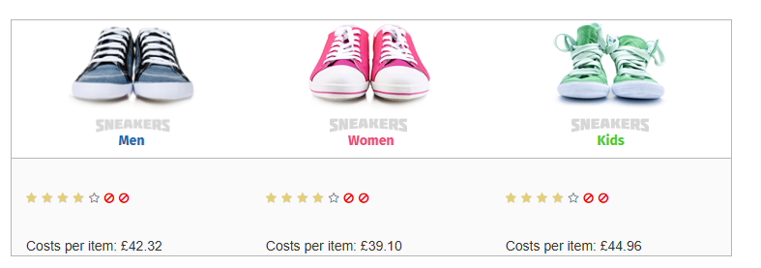

**Figure 2: Products Price**

*(Source: Edumundo, 2024)*

**3.1.2 Market**

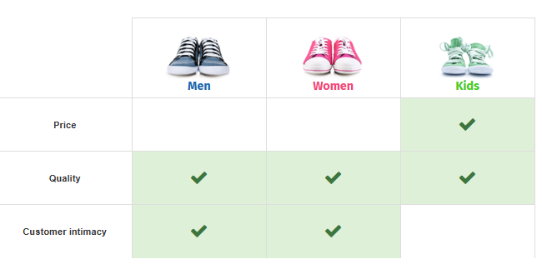

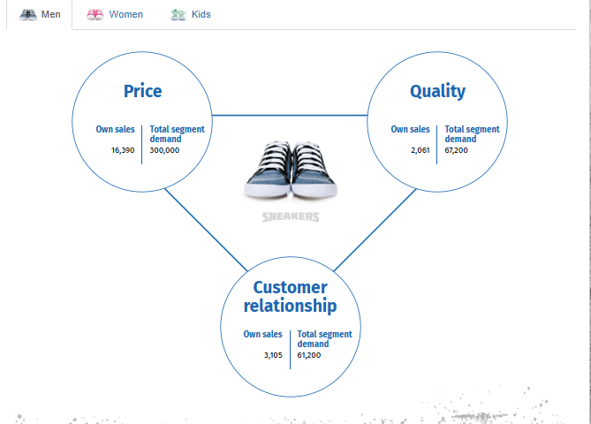

**Figure 3: Market 2024- Men Sneakers**

*(Source: Edumundo, 2024)*

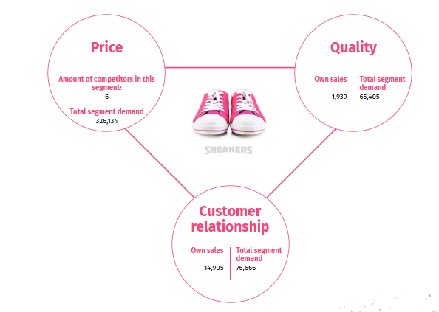

**Figure 4: Market 2024- Women’s Sneakers**

*(Source: Edumundo, 2024)*

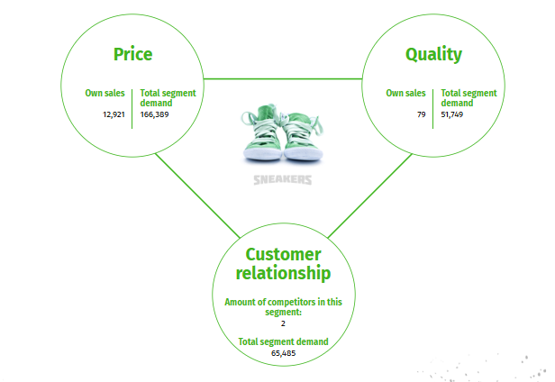

**Figure 5: Market 2024- Kid’s Sneakers**

*(Source: Edumundo, 2024)*

The company’s own sales for the quality segments are men’s (1,939), women’s (1,939), and kids (79). The customer relationship sales are much higher for men’s (3105), women’s (14905), kids (65485). The price segment for men’s is only moderately competitive, with 6 competitors in total market value of 300,000. There are blanks which are still in responding to a full quality requirement of 67,200 and the customer relationship demand at 61,200, suggesting that both have opportunity for growth. There is therefore the potential to gain a larger market share if these segments are expanded.

**3.1.3 4Ps**

**A. Price**

Men sneakers =60£

Women= 55£

Kids= 50£

**B. Place**

**Intensive distribution –** Intensive distribution guarantees that your product reaches as many outlets as possible while focusing on the number of outlets significantly. This particularly gets improved to your stance on the price–market (Hou, 2023).

**C. Promotion**

**Website**

Website positioning (Website positioning Popularisation)- WPP optimises the ranking of websites in public search engines. Your choices are: comprises of no optimization (no additional cost), basic optimization (£10.000) and advanced optimization (£25. 000) (Edumundo 2024).

**3.1.4 Balance Sheet**

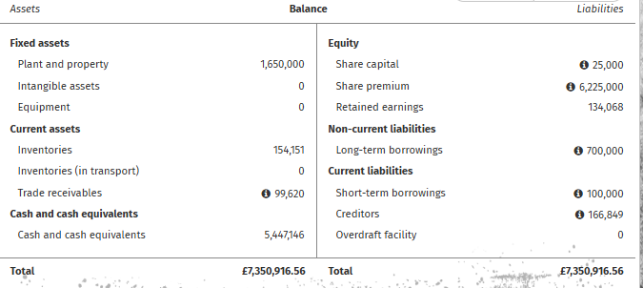

**Figure 6: Balance Sheet -2024**

*(Source: Edumundo, 2024)*

Fixed assets of the company were reduced by £50,000, while current assets were up and included more inventories (£154,151) and trade receivables (£99,620). Again, cash and cash equivalent position was up by a little to £5,447,146. Liabilities were down as long-term borrowings reduced to £700,000 although new credit balances (£166,849) emerged. Our analysis of the absolute values of retained earnings shows that in 2024 there is better financial performance, £134,068 (Edumundo 2024).

**3.1.5 Inventory**

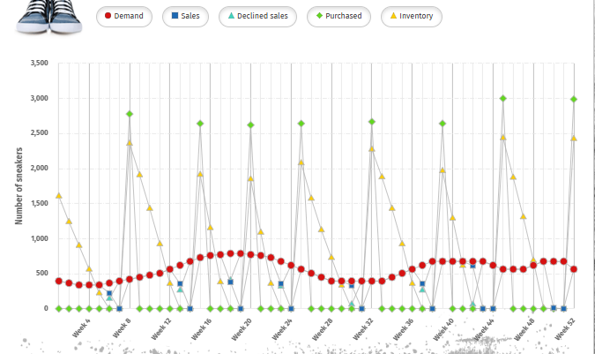

**Figure 7: Inventory 2024**

*(Source: Edumundo, 2024)*

Demand in year 2024 returns to variability and more specifically has important spikes during Week 16 and Week 40, leading to stock out conditions and decreased sales. While purchases are made to restock inventory, it is done in a reactive manner, leaving many sales opportunities unfulfilled during the targeted weeks. For further enhancement, company should emphasize on the areas of demand forecasting, existence of a safety stock, and on shortening of supplier lead times in order to increase inventory accessibility and reduce lost sales.

**3.1.6 Staff**

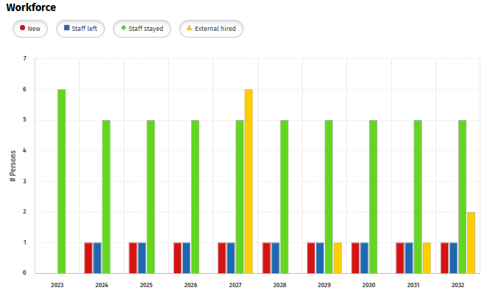

**Figure 8-: Staff Comparison over years**

*(Source: Edumundo, 2024)*

Staff stability remained intact by having 6 members of the team. For the new employees on board the number was few, while others left the company or organization. There were no new hires from outside the organisation this year.

### **Outcomes**

Solex concrete market has been achieved by the year 2024 mainly because of cost leadership and the projected opportunity to achieve improvement on the quality of sneakers as well as improvement on customer relation segments all while selling sneakers at affordable prices. While analysing the sales performance, there was a more overall stronger customer relation but the price segment remained still moderate. Effectively the financial strength of the company enhanced it had high inventory and trade receivables in addition to decrease in long term borrowings (Njemanze, 2021). Nevertheless, some issues arose with inventory control as the times when it runs out of stock during the high demand periods and therefore needs improvement in demand forecasting and suppliers’ lead time. Despite little changes made in its staffing, there was absence of staff hiring but low turnover rate as well.

### **Lessons Learned**

|  |  |
| --- | --- |
| Lesson Learned | Key Takeaways |
| Market Expansion Opportunity | Focus on expanding quality and customer relationship segments for growth. |
| Inventory Management | Implement better demand forecasting and reduce lead times to prevent stockouts during peak demand periods. |
| Financial Planning | Strengthen cash flow management and prioritize reducing liabilities to improve financial health (Njemanze, 2021). |
| Competitive Pricing Strategy | Continue to target price-sensitive customers while maintaining a competitive edge in the market. |
| Staffing | Ensure better recruitment strategies to increase team strength and stability, especially for future growth. |

## **3.2 Year 2: Enhancing Customer Engagement- 2025**

### **Decisions Made**

**3.2.1 Market**

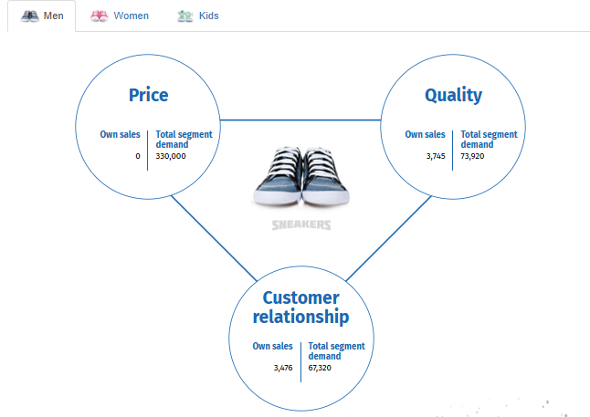

**Figure 9: Market 2025- Men Sneakers**

*(Source: Edumundo, 2024)*

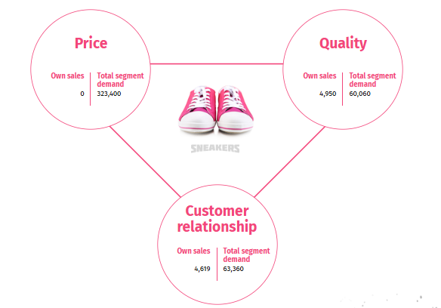

**Figure 10-: Market 2025- Women’s Sneakers**

*(Source: Edumundo, 2024)*

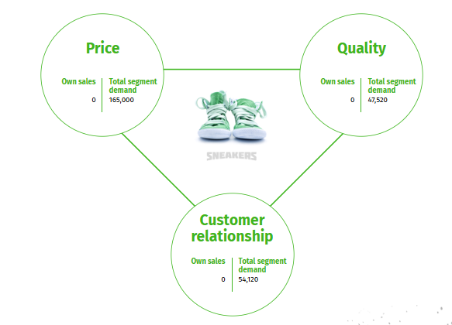

**Figure 11-: Market 2025- Kid’s Sneakers**

*(Source: Edumundo, 2024)*

Similarly, the actual sales expectations of company’s own branded product in quality (3,745) and customer relationship (3,476) are significant though lower than the segment demands in 2025. There were no own sales in the price segment, for all men’s, women’s and kids. Though the total market was rather large and amounted to 3,300,000 for men’s, 323400 for women’s, and 165,000 for kids. The current quality requirement stands at 73,290 and customer relationship need at 67,230; therefore, the company has a problem in these two categories. In order to capitalize on these opportunities, there is a need to enhance the company’s standing in the price segment and address a previously unmet demand in improving the quality and customer relations (Rhee, and Lee, 2021).

**3.2.1 SWOT Analysis Contribution**

|  |  |
| --- | --- |
| Strength | Weakness |
| Strengths   * Brand Recognition * Innovation & Technology * Supply Chain & Distribution * Sustainability Initiatives * Celebrity/Influencer Endorsements   (Rhee, and Lee, 2021). | * Change in consumer behaviours * Price Sensitivity * High Production Costs * Limited Product Differentiation * Supply Chain Disruptions |
| Opportunity | **Threat** |
| * Expansion into Emerging Markets * E-commerce Growth * Customization & Personalization * Athleisure Market * Collaborations & Partnerships * Sustainable Products | * Intense Competition * Counterfeit Products * Economic Downturns * Shifting Consumer Preferences * Fluctuating Raw Material Prices * Regulations & Tariffs (Rhee, and Lee, 2021). |

**3.2.2 Balance Sheet**

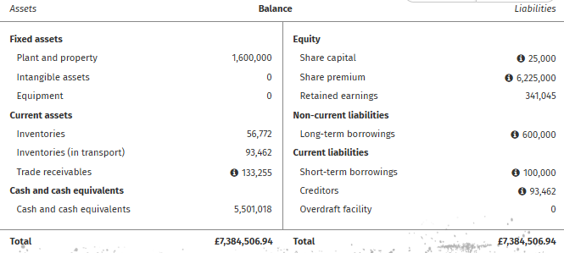

**Figure 12: balance Sheet 2025**

*(Source: Edumundo, 2024)*

As noted by the company in its financial statement, its fixed assets reduced to £1,600,000 in the year 2025. Current assets showed mixed changes: Taking inventories as an account, it reduced to £ 56,772 while inventories in transport were £ 93,462 and the trade receivables raised to £133,255. Other working capital increased to £5,501,018. Evaluating liability presented less of an amount with the long-term borrowings lowered to £600 000 as well as creditors to £ 93 462. The retained earnings were also better in the year or at £341,045 (Rhee, and Lee, 2021).

**3.2.3 Inventory**

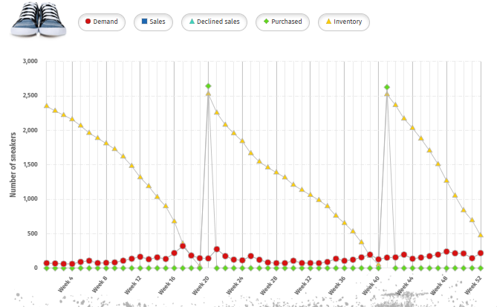

**Figure 13: Inventory 2025**

*(Source: Edumundo, 2024)*

Inventory graph show big chunks of procurement at certain times of the year such as week 20, 40 and 48 while slowly depleting over the following weeks due to constant usage and sales. When supply is largely constant, large stocks in some weeks indicate wastage and low sales at other times point towards misestimation of actual demand levels. Purchasing products in a balanced manner and conducting frequent check on the stock could help to manage stocks effectively in order to cut costs.

**3.2.4 Staff**

The workforce was consistent in that 6 staff members stayed onboard. New members to our staff came in small numbers we also recorded a few people who resigned from the company. There were no external hires (Rhee, and Lee, 2021).

### **Outcomes:**

The company’s performance for the year 2025 reflects a good result in the quality segment of performance and customer relation segment of performance but a poor result in the price segment of performance where the company failed to record any level of sales. However, to the total market, price was too large for the company to meet the quality and customer relationship requirements which showed the areas that need enhancements. In the financial aspect, there was also an enhancement in the aspect of fixed assets as well as long term borrowings and the organization had more retained earnings of £341,045 (Rhee, and Lee, 2021). Nevertheless, some challenges persisted and they were on the inventory where there were irregular purchases of stocks in certain weeks while others remained almost empty due to poor estimation of demand and stock control mechanisms.

1. **Financial KPIs**:

|  |  |  |  |
| --- | --- | --- | --- |
| KPI | Description | Target | Performance in Year 2 |
| Retained Profit | Profit as a percentage of net turnover (Heo, et al., 2023). | €500,000 - €2,500,000 | Achieved lower range of target. Improved by 10% from Year 1. |
| Solvency | Owner’s equity to total assets ratio. | 50% | Met the target ratio. |
| Highest Quality | Average ranking in quality-oriented market segments. | 3-5 | Maintained within target. |
| Education Level of Staff | Percentage of educated and trained employees (Rhee, and Lee, 2021). | 60% | Reached 55%, nearing the target. |
| Staff Motivation | Employee loyalty and performance improvement. | Improved staff performance and loyalty. | Enhanced through training and motivation strategies. |

### **Lessons Learned:**

|  |  |
| --- | --- |
| Lesson Learned | Key Takeaways |
| Market Segmentation | Focus on addressing gaps in the price segment to capture market share. |
| Inventory Management | Regular monitoring and balanced stock purchasing are essential to avoid wastage and optimize sales. |
| Financial Management | Improve cash flow and work towards reducing long-term liabilities to increase financial stability (Heo, et al., 2023). |
| Customer Engagement | Enhance strategies to better align product offerings with the quality and customer relationship demands. |
| Staffing | Consider expanding the workforce to bring in new talent for growth and stability in the long run. |

## **3.3 Year 3: Leveraging Market Penetration Strategy- 2026**

### **Decisions Made:**

**3.3.1 Market**

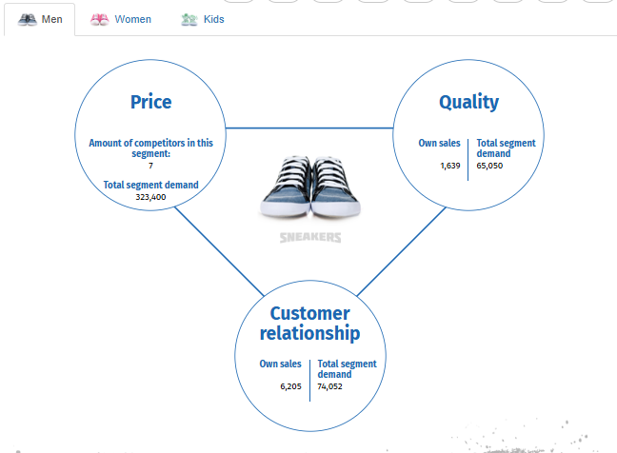

**Figure 14: Market 2026- Men Sneakers**

*(Source: Edumundo, 2024)*

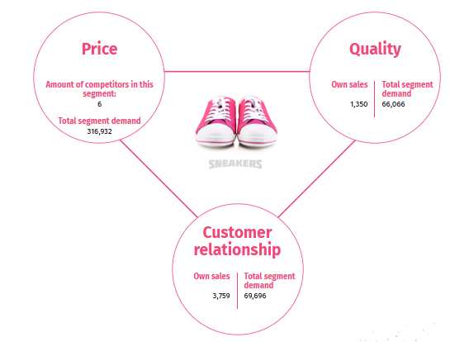

**Figure 15: Market 2026- Women’s Sneakers**

*(Source: Edumundo, 2024)*

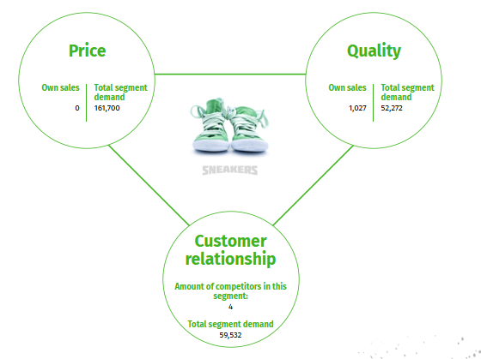

**Figure 16: Market 2026- Women’s Sneakers**

*(Source: Edumundo, 2024)*

Company has reported 6205 for own sales for quality in the year 2026 and 6205 for customer relationship with seven competitors in segment. Nevertheless, the company still retains a relatively forward position in the customer relationship sales competition. This shows that the total price segment lacked the capability to meet both quality requirement that cost 65,050 and the customer relationship demand that costs 74,052 while the total price segment is valued at 32,340. The opportunities to improve the situation are to increase the level of differentiation and to expand supply into both higher quality and lower price segments to serve the unserved demand.

**3.3.2 Balance Sheet**

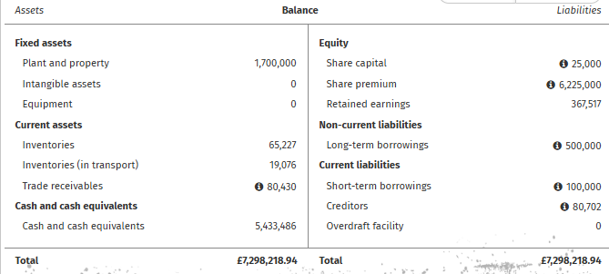

**Figure 17: Balance Sheet -2026**

*(Source: Edumundo, 2024)*

Plant and property in the financial year ending 2026 was £1,700,000. Stocks increased to £65,227 from £60,398 and stocks in transit decreased to £19,076 from £29,523. Trade receivables reduced to £ 80,430 and cash in hand reduced to £ 5,433,486 a little. Long-term borrowings go down to £500,000 and creditors get down to £80,702. The retained earnings rose to £367, 517 (Edumundo, 2024).

**3.3.3 Inventory**

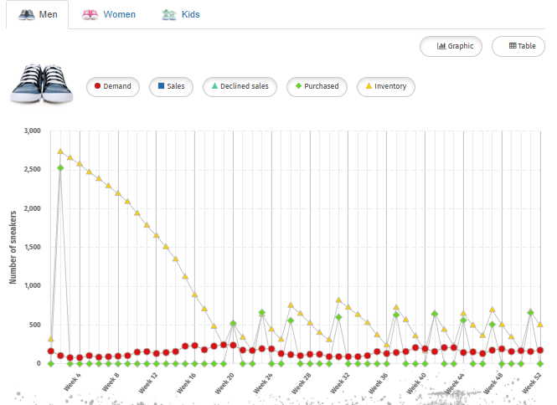

**Figure 18: Inventory 2026**

*(Source: Edumundo, 2024)*

Inventory graph for year 2026 shows better variation between demand and inventory than earlier years. They are not made in large quantities thus inventory consumption flows more evenly, decreasing holding costs. Over time, requests are dominated and few sales declined point to a reasonable match of stock with the market demand. This implies efficient changes in procurement approach and holding that outcome in the utilization of resources as well as the minimization of unnecessary expenditure (Edumundo, 2024).

**3.3.4 Staff**

The stability of staff continued as 6 remained with their employer. A couple or new hires occurred herein midst of the organization to moderate the few cases of turnover. There was no case of a direct recruitment from outside the company.

### 

### **Outcomes:**

The establishment was able to perform well in customer relationship sales in 2026, while it had to deal with seven competitors. However, the quality and price segments remain insufficient to meet the necessary requirements, which can act as improvement suggestions. More specifically, the company pursued differentiation strategy and supply growth in both the quality and the lower price tiers which were recognized as the gaps in the market (Hou, 2023). In terms of financial position, the company had better retained earnings of £367,517, reduced long term borrowings and enhanced working on inventory procurement and consumption.

### **Lessons Learned:**

|  |  |
| --- | --- |
| Lesson Learned | Key Takeaways |
| Market Penetration | Continue expanding into both high-quality and affordable price segments to meet unmet demand. |
| Inventory Management | Efficient procurement and stock consumption are key to minimizing costs and aligning with market demand. |
| Financial Stability | A focus on reducing long-term borrowings and increasing retained earnings enhances financial health (Consuma Technologies Pvt Ltd, 2024). |
| Differentiation Strategy | Increasing product differentiation is crucial to staying competitive in crowded market segments. |
| Staffing Strategy | Maintain employee stability while selectively hiring to address skill gaps and support growth. |

## 

## **3.4 Year 4 - Managing Inventory Effectively- 2027**

### **Decisions Made**

**3.4.1 Market**

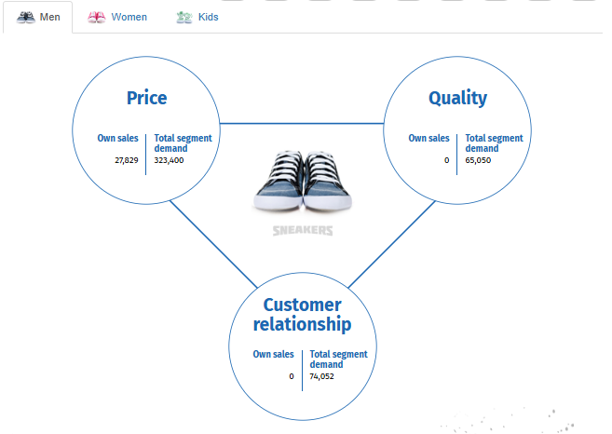

**Figure 19: Market 2027- Men Sneakers**

*(Source: Edumundo, 2024)*

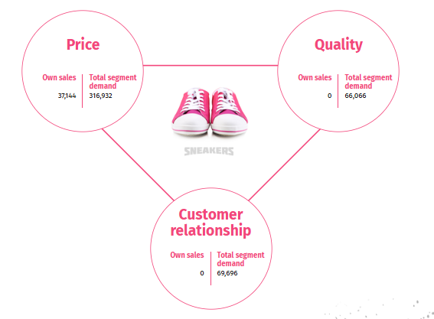

**Figure 20: Market 2027- Women’s Sneakers**

*(Source: Edumundo, 2024)*

The company had no own sale in quality or customer relationship in 2027, however, it gained 27,829 own sales for the price segment and the total market segment was 323,400. Nevertheless, the quality requirement of 65,050 and customer relationship demand of 74,052 still exist. It is crucial for the company to pay more attention on the Sales, scope, depth and variety sides so as to make up for the shortcomings in the quality and customer relation segments while keeping the price segment as a competitive area.

**3.4.2 Balance Sheet**

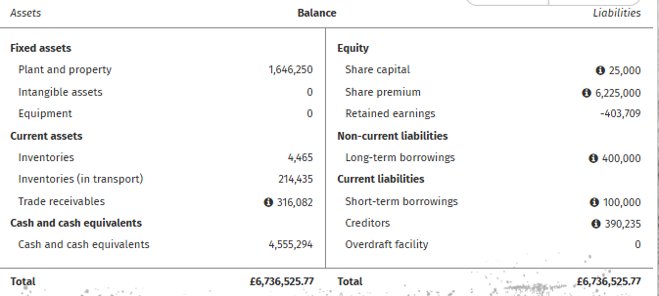

**Figure 21: Balance Sheet 2027**

*(Source: Edumundo, 2024)*

For the year ending 2027, the plant and property reduced to £1,646,250. They sank to £4,465 whereas inventories in transport went up to £214,435. Trade receivables increased to £316,082 while cash and cash equivalents dropped to £4,555,294. Long-term borrowings were decreased to £400, 000 and creditors have been raised to £390,235. The retained earnings became a negative figure of £ -403,709 (Edumundo, 2024).

**3.4.3 Inventory**

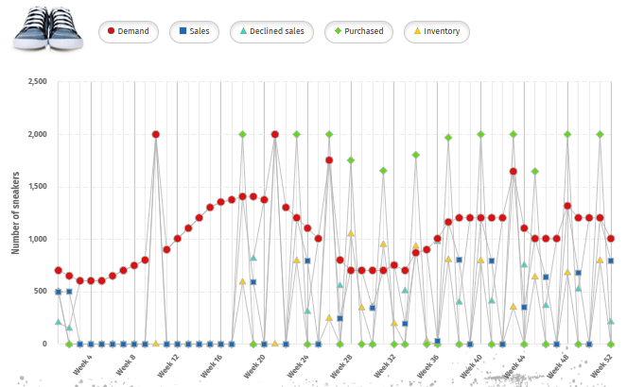

**Figure 22: Inventory 2027**

*(Source: Edumundo, 2024)*

The variation in inventory for the year 2027 is very high and maintains a very high number of 2,000 units per sale in the certain weeks of the particular year, such as Week 10, 21 and 43. Stock is often replenished in order to meet the demand but it is possible and actually happens that demand remains unheard (Week 3 to Week 9). Such weeks, for instance Week 10 with high demand match with the immediate restocking plans to reduce the period of stock out (Edumundo, 2024). In general, supply procurement seems to be unanticipated, with products bought chiefly during peak periods, implying the need for optimization of inventory prediction and refractive restocking practices to address the abnormalities in the inventory trends throughout the year.

**3.4.4 Staff**

Externally acquired hires increased to a maximum level of (6) while staff retention level reduced to (5) in the same year. Fresh enlistments or joining the organization for the first time were also observed while some staff members exited the workplace.

**3.4.5 Purchase Decisions**

For each type of sneaker, decisions are made based on inventory levels and supplier terms.

**Men’s Sneakers (Distributor: ZWOLAWSKI and ZWOLAWSKI):**

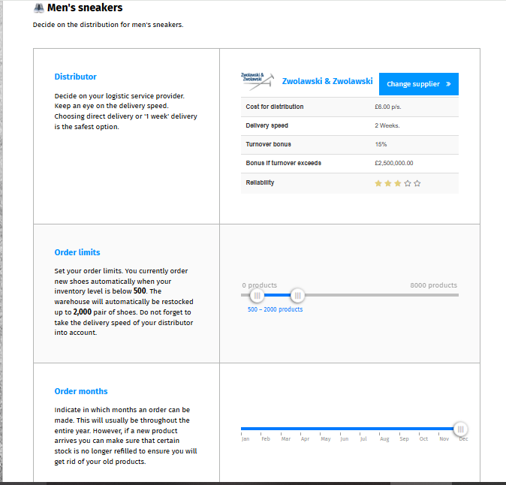

**Figure 23: Distributor of Men’s Sneaker**

*(Source: Edumundo, 2024)*

|  |  |
| --- | --- |
| **Category** | **Value** |
| Cost per unit | £6 |
| Turnover bonus | 15% (if turnover exceeds £2,500,000) |
| Reliability | 3 stars |
| Order Process | Automatic replenishment at 500 units, restocked in 2000-unit quantities monthly |
| Challenges | This assures everyone that the turnover bonus is only going to be advantageous if sales reach £2,500,000. If this target is not achieved a unit profit margin is however reasonably low considering the fact that distribution has higher fixed costs (Shaw, 2024). |

**Women’s Sneakers (Distributor: ZWOLAWSKI and ZWOLAWSKI):**

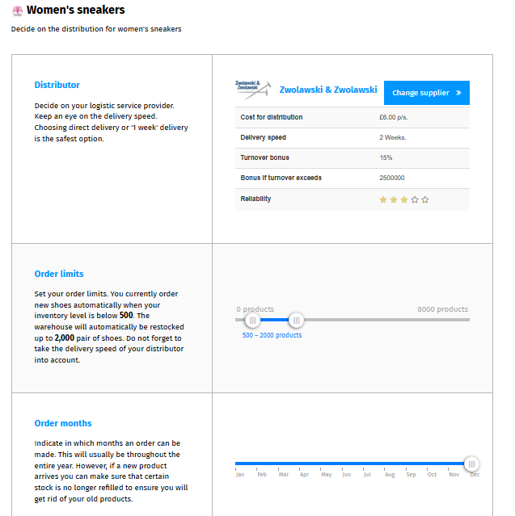

**Figure 24: Distributor of Women’s Sneaker**

*(Source: Edumundo, 2024)*

|  |  |
| --- | --- |
| **Category** | **Value** |
| Cost per unit | £6 |
| Turnover bonus | 15% (if turnover exceeds £2,500,000) |
| Reliability | 3 stars |
| Order Process | Reorder at 500 units, order 2000 units monthly |
| Challenges | High turnover bonus requires sufficient sales volume to be profitable (Edumundo, 2024) |

**Kids’ Sneakers (Distributor: LTC):**

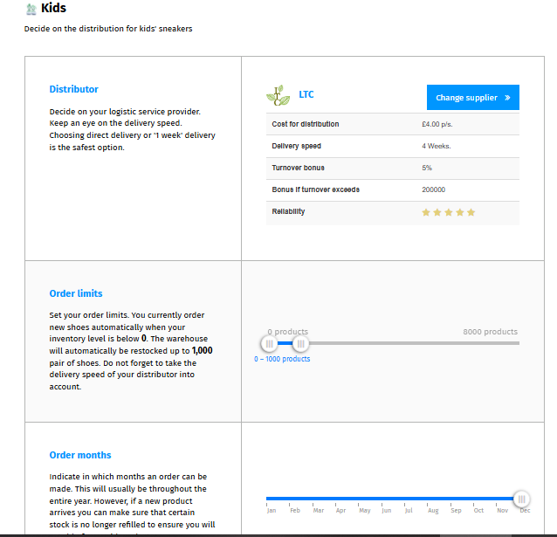

**Figure 25: Distributor of kid’s Sneaker**

*(Source: Edumundo, 2024)*

|  |  |
| --- | --- |
| **Category** | **Value** |
| Cost per unit | £4 |
| Turnover bonus | 5% (if turnover exceeds £200,000) |
| Reliability | 5 stars |
| Order Process | Reorder at 0 units, restock up to 1000 units monthly |
| Challenges | Delivery speed (4 weeks) may cause stockouts, but reliability and lower cost in the long run are advantages |

**2. Financial Analysis**

Comparing the balance sheet and the purchase terms, the company has plenty of cash £5,447,146 consisting of cash and cash equivalents. This makes it easy to negotiate for the procurement of the larger quantities of the product to meet demand for sneakers.

**Cash Flow Considerations:**

* **Men’s and Women’s Sneakers (ZWOLAWSKI and ZWOLAWSKI):**

The cost of distribution (£6 per pair) is comparatively high and there is a turnover incentive for £25000 but can only be gained if sales over £2,500,000 are achieved.

One can lift the degree of marketing communication or change the strategies of pricing to achieve the turnover rate and profit higher margins of the turnover bonus.

* **Kids’ Sneakers (LTC):**

It costs £4 per unit with a more realistic turnover bonus threshold of £200,000.

After analysing the 5-star reliability rating, it may be argued that LTC is absolutely more reliable long-term supplier even with lower velocity (Shaw, 2024).

One of these should be to choose the approach of increasing skate sales for children, which, given the most commonplace cost per pair, might bring more profit.

* **Order Limits and Inventory Management:**

The automatic reorder system helps to remember the stock levels thus avoiding situations where there is no stock.

But there can be overstock if demands are not forecasted in the correct way leading to tied up cash in inventory.

### **Outcomes**

* Increased Sales: There is also a chance to receive a 15% turnover bonus if the company reaches its sales targets of men and women sneakers this would indeed improve profitability greatly. As for kids’ sneakers, cost and the 5% bonus would follow similar path and help stabilize margins (Conceição, et al., 2021).
* Stockouts or Overstocking: The automatic reorder system applied to keep sufficient supplies of products is rather effective, yet doing it more often while selling kids sneakers can lead to the overstocking of the outlet or conversely, missing the desired sales rates due to slow order delivery.
* Cash Flow Management: The high cash reserve position implies that the company is positioned well to face variability in its inventory requirements but must avoid buying in large quantities of inventory in a particular period or quarter since sales are likely to be slow.

### **Lessons Learned**

* Forecasting is Key: Availability is the extent to which a product is available in the market when it is needed avoiding both stockouts and overstocking. In the situation when the sales volume is not significant enough to achieve the turnover bonuses, this may affect the entire profitability (Conceição, et al., 2021).
* Supplier Relationships Matter: ZWOLAWSKI and ZWOLAWSKI are valid current suppliers for men’s and women’s sneakers whereas LTC can probably be considered a 5-star more reliable partner in providing kids sneakers due to a slower moving product.
* Effective Use of Cash Flow: The company has liquidity and, therefore, working capital flexibility; however, it should avoid placing too much cash in the inventory. The smooth movement of cash in and out of the business is highly essential in fund management so that business operations can continue without much strain on funds (Conceição, et al., 2021).
* Optimize Marketing for Bonus Thresholds: It is important that the organization strives to meet the thresholds of turnover bonus. Spending money on advertising the men’s and women’s sneakers may go a long way in increasing sales and attaining the bonus.

## **3.5- Year 5- Sneakers Market Analysis- 2028**

### **Decisions Made**

**3.5.1 Market**

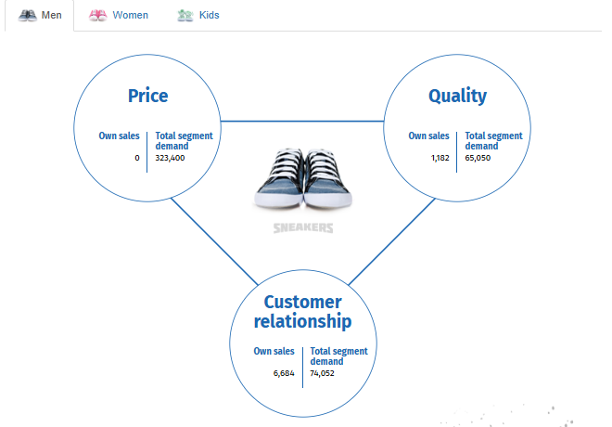

**Figure 26: Market of Men’s sneakers- 2028**

*(Source: Edumundo, 2024)*

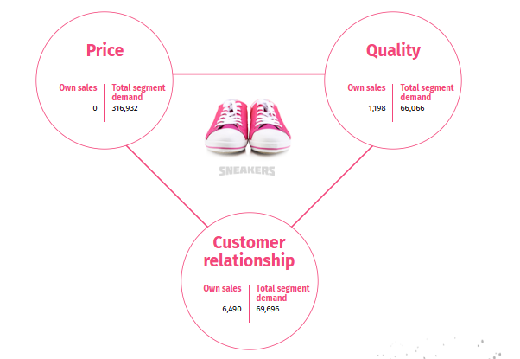

**Figure 27: Market of Women’s sneakers- 2028**

*(Source: Edumundo, 2024)*

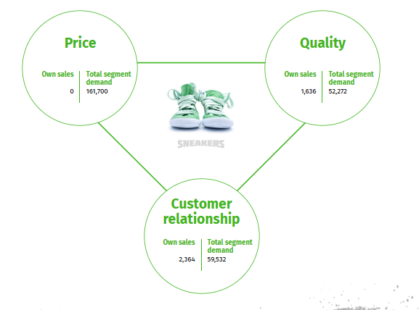

**Figure 28: Market of Kid’s sneakers- 2028**

*(Source: Edumundo, 2024)*

For the year 2028, own sales for quality were 1,182 for men’s, 1636 for kids, and 1198 for women’s and customer relation was 6,684, 6490 for women’s and 59532 for kids. The company however did not record any sales in the price segment, though the overall market volume was men (323,400), women’s (316932), and kids (161700). The organisation has unrealised quality need (65,050) and customer relationship need (74,052). For the improved performance the company requires to concentrate on strategic business unit, more particularly on the price segment to enhance the opportunity to carry out sales rather than concentrating on the issues with relation to quality and customer relations.

**3.5.2 Balance Sheet**

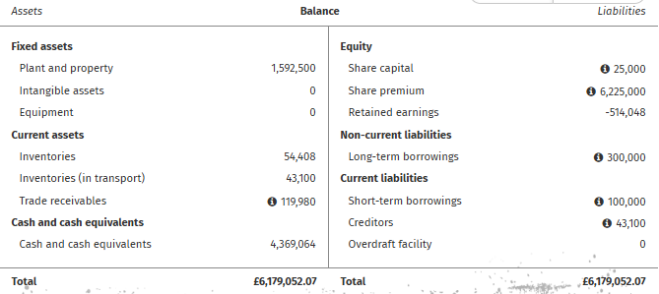

**Figure 29: Balance Sheet- 2028**

*(Source: Edumundo, 2024)*

By 2028, plant and property went down to £1,592,500. They increased inventories to £54,408 and inventories in transit reduced to £43,100. Trade receivables were £119,980 and cash £4,369,064. Long-term borrowings fell to £300,000 during the year, and creditors declined to £43,100. To the end of the financial year, retained earnings were still in deficit and stood at £-514,048 (Edumundo, 2024).

**3.5.3 Inventory**

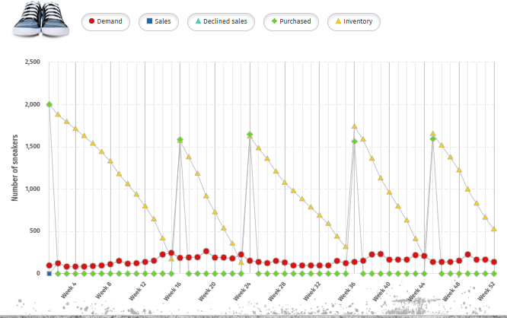

**Figure 30: Inventory- 2028**

*(Source: Edumundo, 2024)*

The data obtained from the simulations of the content of stock by the end of 2028 showed constant demand with some oscillations and occasional increase, for instance, in Weeks 16, 24, 36, and 45 when it was required to buy more products, despite modest overall demand in these weeks. The raw material inventory is fairly stable as driven by strategic purchasing plan and warm stock policy to avoid stock out situations and have adequate stock to meet any demand. For instance, larger purchases are recorded in Weeks 16,24, 36 and 45, followed by slightly higher demand in the subsequent weeks ensuring that I had a good balance of stocks on hand. This pattern shows good demand forecasting coupled with restocking practices that keep operations smooth and that prevent volatile disruptions.

**3.5.4 Staff**

Stability was brought back as 6 remained out of the total staff strength, with a few new joiners and separations. Drastic decline from the previous year’s high, external recruitment again came down to different levels.

### **Outcomes**

In 2028, company performed poor in the aspect of price segment, with no sales record even though the market volume was huge. The other segment posted was – Quality & Customer Relationship which also reflected an untapped or below par performance. From the financial performance point of view, plant and property depreciated and inventories appreciated, while retained earnings were reported deficit. Inventory control was enhanced by a good purchasing schedule matching the purchasing plan and the demand of the cycles. There were no significant variations in staffing levels with most staffs recruited internally (David, et al., 2021).

### **Lessons Learned**

|  |  |
| --- | --- |
| Lesson Learned | Key Takeaways |
| Price Segment Focus | Focus on increasing sales in the price segment to capture untapped market opportunities. |
| Financial Health | Prioritize improving retained earnings and reducing financial deficits for stronger profitability. |
| Inventory Management | Improved demand forecasting and strategic purchasing are essential for managing stock levels efficiently (Shaw, 2024). |
| Staff Stability | Maintaining staff stability while managing turnover and ensuring the right skills are onboard is crucial for operational continuity. |
| Segment Demand Alignment | Ensure a better alignment between product offerings and market demand in all segments (quality, customer relations, and price). |

## 

## **3.6- Year 6- Consumer Preferences for Men's and Women's Sneakers"- 2029**

### **Decisions Made**

**3.6.1 Market**

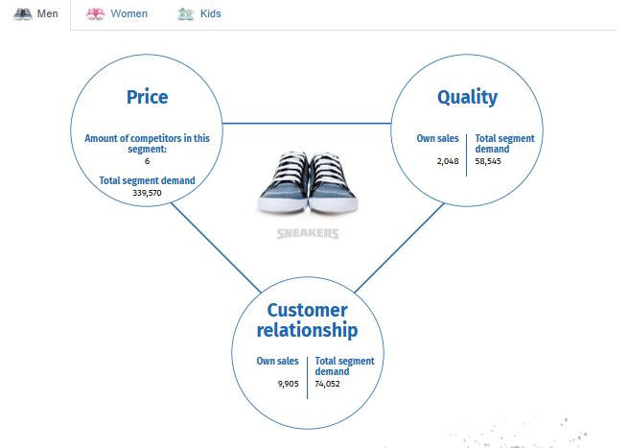

**Figure 31: Market of Men’s sneakers- 2029**

*(Source: Edumundo, 2024)*

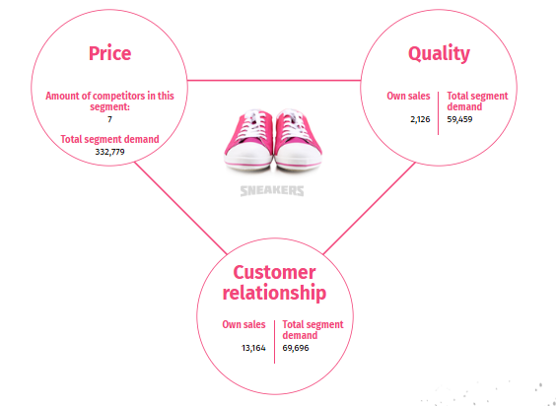

**Figure 32: Market of Women’s sneakers- 2029**

*(Source: Edumundo, 2024)*

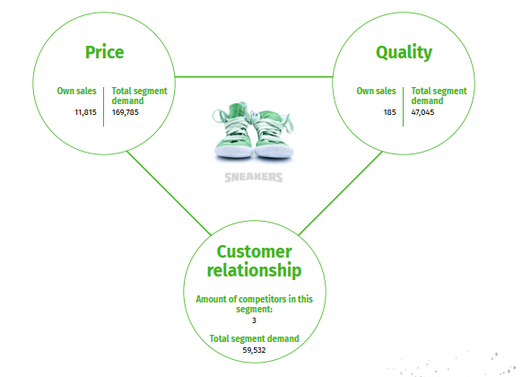

**Figure 33: Market of Kid’s sneakers- 2029**

*(Source: Edumundo, 2024)*

For this segment, in 2029, the company reached 2048 own sales for quality, and 6684 customer relationship with six competitors. The total pricing segment appears at 339,570 but the company has unrealized quality need of 58, 545 and customer relation need of 74, 052. In customer relationships, especially in sales volume, the company has a good performance; however, the company’s market share in the quality type is relatively small, and the price has a large gap with the demands of the market.

**3.6.2 Balance Sheet**

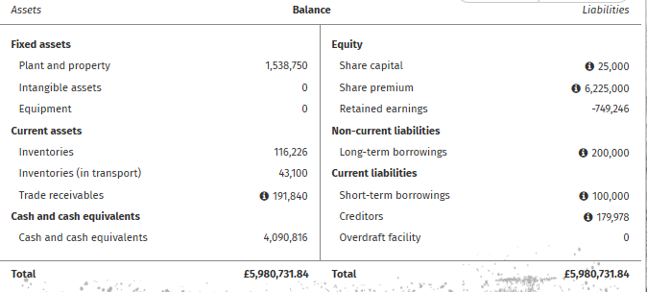

**Figure 34: Balance Sheet- 2029**

*(Source: Edumundo, 2024)*

For the year ending in 2029, plant and property had reduced to £1,538,750. Stocks also rose to £116,226 while stocks in transit were £43,100. Trade receivables increased to £191,840 while cash increased to £4,090,816. Fixed loan facilities reduced to £200 000 while sundry credits rose to £179,978. Equity and reserves exhibited a retained earning negative figure of £-749, 246 (Edumundo, 2024).

**3.6.3 Inventory**

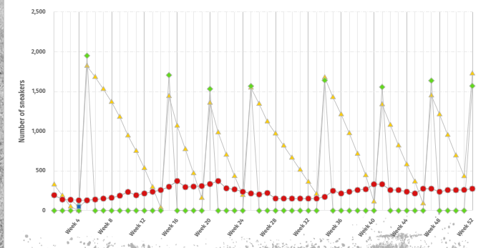

**Figure 35: Inventory- 2029**

*(Source: Edumundo, 2024)*

Inventory management for the year 2029 is also done in relation to the trends registered in the previous years and it means getting the inventories in good time to enable the organization be ready for the increased demand for the products.

**3.6.4 Staff**

However, the workforce was moderate with six staff being retained in the company. Little change in new hires; few staffs gained and few staffs lost. No external hires were made.

**3.6.5 Targeted Product Line Expansion:**

For men’s sneakers, the quality was enhanced at the £20–£40 price point, and new products were introduced at the £60–£80 price point to retain the company’s market dominance.

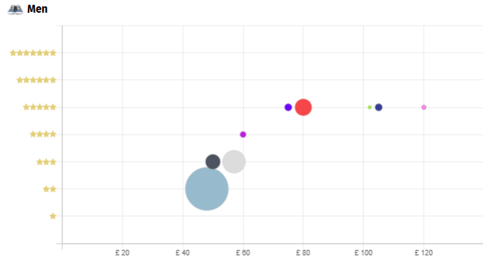

**Figure 36: Men’s Product Line**

*(Source: Edumundo, 2024)*

Selecting Women Sneakers, new entry product line (£20- £40) to meet the consumers’ value sensitive needs and special offers for high end products (£80- £120).

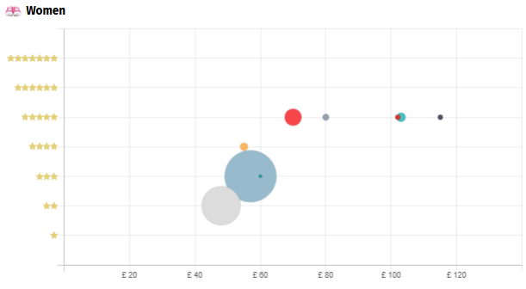

**Figure 37: Women’s Product Line**

*(Source: Edumundo, 2024)*

### **Outcomes**

Specific to the year 2029, special advancement was achieved where company demonstrated a good sales achievement in customer relationship. However, it still struggled in the quality segment, with low market share and still, the unsatisfied demand. The match up gap was also observed in the price segment which clearly exhibited that there is a potential to penetrate its market fully (Zhu, et al., 2021). On the financial side, most business plant and properties depreciated because its value declined, but on the stock side, stock and trade receivables rose because there is where live movement of products. However, the figure of retained earnings in company’s equity and reserves reflects the existing financial troubles. Inventory management was somewhat improved and better tailored to demand better addressing the need for more products. The staff population was relatively stationary for the year with low turnover rates.

### **Lessons Learned**

|  |  |
| --- | --- |
| Lesson Learned | Key Takeaways |
| Quality and Price Segment Focus | Focus on closing the gap in the quality and price segments to fully capitalize on market demand. |
| Market Expansion | Expanding the product line with targeted offerings for both lower and higher price points can help capture a broader customer base (Raditya, and Hanaflah, 2021). |
| Financial Stability | Addressing negative retained earnings is critical for achieving long-term financial stability. |
| Inventory and Demand Management | Continued refinement of inventory management practices ensures stock availability aligns with demand surges. |
| Staffing and Workforce Stability | Stable staffing levels are important for operational continuity, with careful management of turnover. |

## **3.7- Year 7- Price Development in the Solex Simulation- 2030**

### **Decisions Made**

**3.7.1 Market**

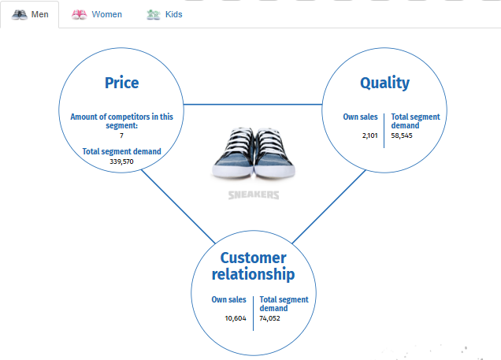

**Figure 38: Men’s Sneakers Market- 2030**

*(Source: Edumundo, 2024)*

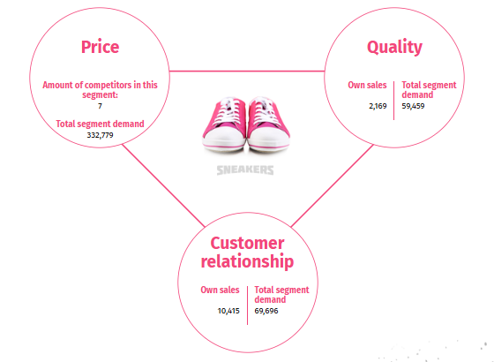

**Figure 39: Women’s Sneakers Market- 2030**

*(Source: Edumundo, 2024)*

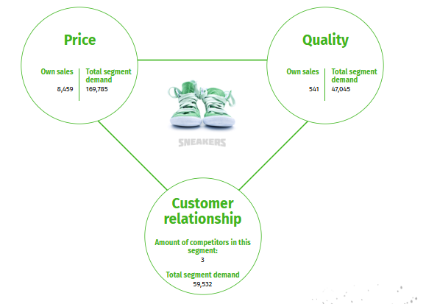

**Figure 40: Kid’s Sneakers Market- 2030**

*(Source: Edumundo, 2024)*

In 2030, the company reached top-line own sales 2,101 for quality and 10,604 for customer relation with seven competitors in the segment. Totally, the total price segment amounts to 339,570, and the company has further quality demands (58,545) and customer relationship not yet met (74,052). Despite the selected customer relationship sales being relatively good, quality sales need to be ramped up in order to achieve efficiency required in the market segment.

**3.7.2 Balance Sheet**

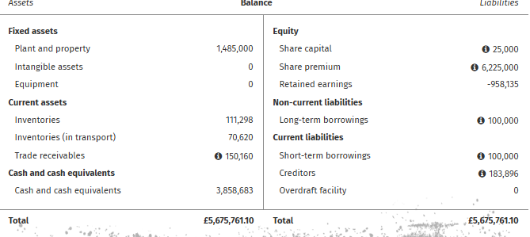

**Figure 41: Balance Sheet- 2030**

*(Source: Edumundo, 2024)*

For plant and property in 2030, it fell to £1,485,000. Stocks dropped to £111,298 while stocks in transit rose to £70,620. Trade receivables reduced to £150,160, and cash and cash equivalents reduced to £3,858,683. Long-term borrowings were cut down to £100,000 and the figure of creditor increased to £183,896. Retained earnings were still a loss figure at £ -958, 135 (Edumundo, 2024).

**3.7.3 Inventory**

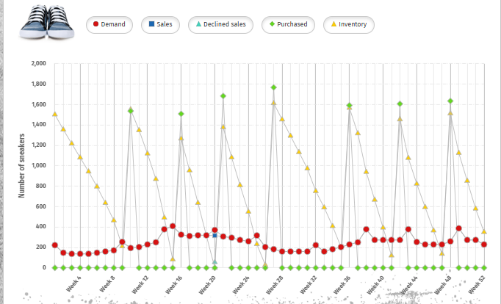

**Figure 42: Inventory- 2030**

*(Source: Edumundo, 2024)*

Inventory management in 2030 thus ensures that there are enough stock, adequate sales to mean that there is no stockout, and acquiring stock in the right measure to avoid overstocking. Major buys in weeks 10, 16, 21, 27, 36, 42 and 48 restock during demand peaks in weeks 14, 15, 38 and 43. It guarantees stock out during periods of high demand and at the same time minimizes inventory stock during low demand trends. It reduces holding costs and guarantees that customer needs are always met when delivering the products.

**3.7.4 Staff**

No much changes were done with 6 of the staff remaining. Only a few new members were admitted, while a couple dropped out. No external hiring was still a practice in the organization.

### **Outcomes**

In 2030, the performance of this company improves a lot and got very good result in this segment. But to cover quality chairs, sales remained unsatisfactory with unfulfilled quality and customer relationship market. Hence the market position of the company remained fairly competitive, but more efforts were needed to enhance the quality sales to get to the standard efficiency needed in the concerned market segment. In terms of the financials, the company endured some problems that concerned plant and property values and cash outlay as well as low cash and money balances, and negative retained earnings (Liu, 2021). There was better inventory management as the company was able to make purchases in tune with demand fluctuations which pleased the company’s customers whilst at the same time avoiding the exponential costs of holding inventory. There was a significant measure of no massive change in staffing since the authorities did not make any notable changes in external hiring.

### **Lessons Learned**

|  |  |
| --- | --- |
| Lesson Learned | Key Takeaways |
| Focus on Quality Sales | Emphasis needs to be placed on improving quality sales to meet market demands and enhance efficiency. |
| Inventory Optimization | Strategic purchasing and inventory management are essential to balance stock levels with demand peaks, minimizing costs and preventing stockouts (Shaw, 2024). |
| Financial Health | Reducing negative retained earnings is crucial for long-term sustainability and financial stability. |
| Market Positioning | While customer relationship sales are strong, maintaining a balanced focus on both quality and price is key to achieving market dominance. |
| Staff Stability | Maintaining a stable workforce with minimal external recruitment supports operational continuity and efficiency. |

## **3.8 Year 8- Evaluating Final Performance- 2031**

### **Decisions Made**

**3.8.1 Market**

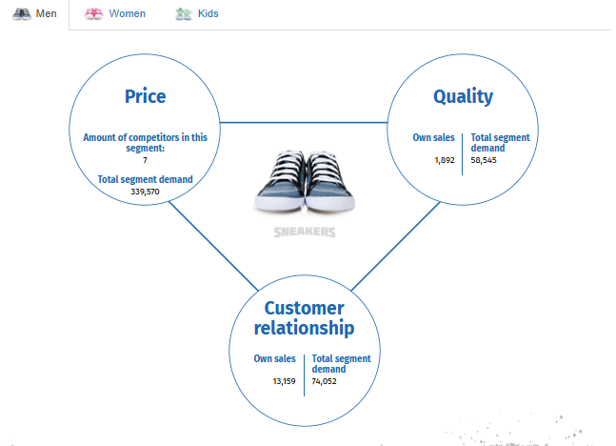

**Figure 43: Men’s Sneakers Market- 2031**

*(Source: Edumundo, 2024)*

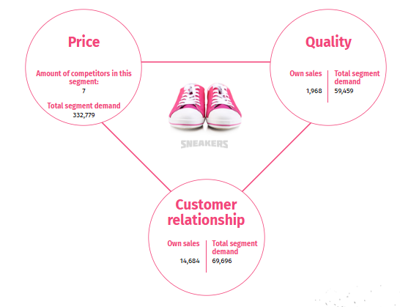

**Figure 44: Women’s Sneakers Market- 2031**

*(Source: Edumundo, 2024)*

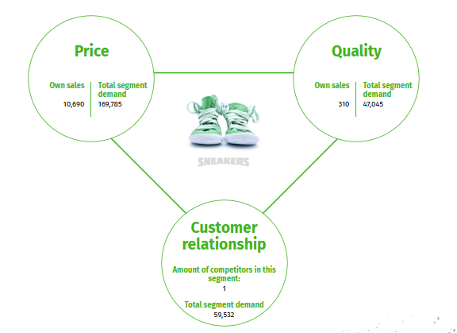

**Figure 45: Women’s Sneakers Market- 2031**

*(Source: Edumundo, 2024)*

In 2031, the company reached 1892 for own sales for quality and 13559 in customers relationship, being served seven competitors in the segment. The total price segment is 339,570 while the unmet quality requirements are 58,545 and customer relationship demand is 74,052. Although the company is impressive in its maintenance of customer relations, it is left with the task of improving quality sales to fit the market and boost competitiveness.

**3.8.2 Balance Sheet**

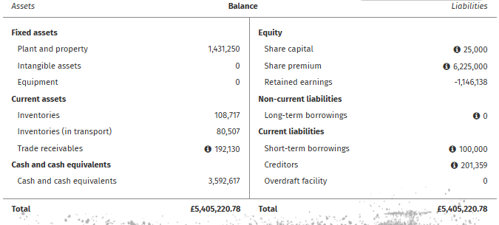

**Figure 46: Balance Sheet- 2031**

*(Source: Edumundo, 2024)*

Plant and property in the same year reveals a value of £1,431,250. Inventories reached £108,717 and inventories in transport supplies were £80,507. Trade receivables were higher at £192130 and cash and cash equivalents down at £3,592,617. None of the long-term borrowings can be seen, whereas the value of creditors rises to £201,359. Accumulated losses were still negative at £-1,146,138 (Edumundo, 2024).

**3.8.3 Inventory**

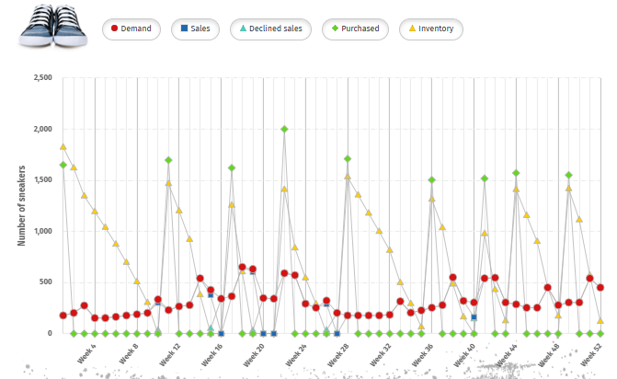

**Figure 47: Inventory - 2031**

*(Source: Edumundo, 2024)*

An obvious relationship between demand and sales exists; however, inventory gaps can be observed in several weeks, for instance, Weeks 10, 15. Orders are made mostly in few weeks for resupply only because most products are already available in the store. Reduced stockout rates may be achievable by enhancing the accuracy of forecasting and stock control. Uninterrupted supplies are advised when it comes to the procurement and supply management to enhance the supply chain.

**3.8.4 Staff**

Staff turnover remained stable; 6 staff members remained at the organisation. A small number of new hires matched the minimal turn-over rate that prevailed in this camp. There were no cases of employing staff from outside the company.

### **Outcomes**

**Final Score:**

* New Total Ranking Score: 2,158.54.
* Points from Progress Towards Targets: 217.38.
* Penalty for Negative Own Capital: 85.59.
* Points Received for Meeting Targets: -125.00.
* Points from Last Round: 1,901.75.

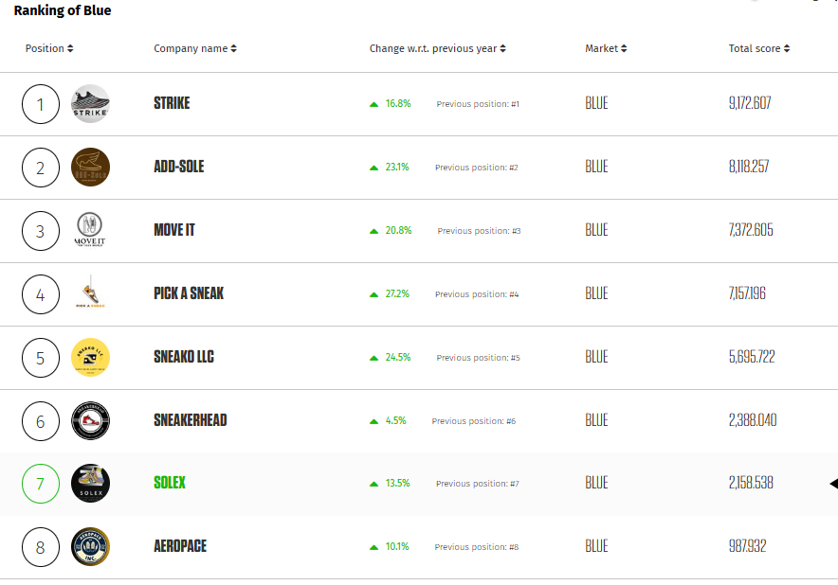

**Figure 48: Overall Ranking of Solex**

*(Source: Edumundo, 2024)*

**Net Profit**

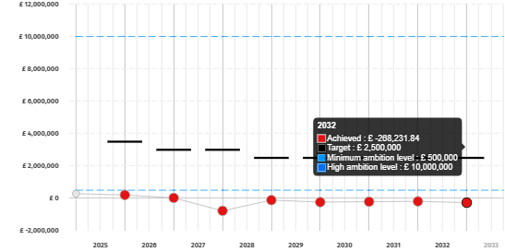

**Figure 49: Net Profit Over years**

*(Source: Edumundo, 2024)*

**Achieved Net Profit:**

* They realized a net loss for the year with £ (288231.84). This is significantly below the set targets and the level of ambition envisioned for Car of the Future.

**Target Levels:**

* The targeted post tax profit was £2,500,000 which has not been achieved by the company.
* The minimum ambition of £500,000 and the high ambition of £10,000,000 were also missed by a very large percent.

**Performance Over Time:**

* The net profit achieved is presented in the Figure 5 in red data points which all point down indicating that there is continuous issue with profitability pursuit.
* All measured targets add up to the indexes of financial performance, and the discrepancy between achievement and goals grows over time, indicating the deterioration of financial results or the lack of addressing organizational systems.

**Quality**

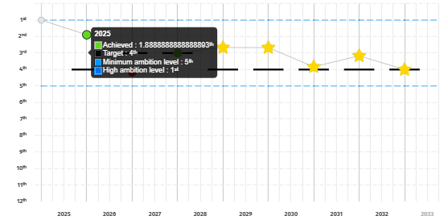

**Figure 50: Net Quality Over Years**

*(Source: Edumundo, 2024)*

**Underachievement:**

* The averaged quality score is 1.89 that is significantly lower than target 4, which confirms that Solex did not supply products with the required quality (Nooh, 2022).
* The difference between the obtained result and the minimum level of aspiration (5) indicates the presence of serious failures in satisfying consumer demand for quality sneakers.

**Comparison to Goals:**

* Solex Corporate performance in the execution of its strategic vision did not relate well with its mission of delivering quality products.

**Quality Trends:**

* It lacks upward trends in the qualitative measure who shows there is a problem with regards to the design and the material to be used or even the manufacturing processes involved (Hinton, 2023).

### **Lessons Learned**

**Pricing and Profit Margins**

* To maintain a profitability level while also avoiding a repeated stream of cheap imitations by competitors, a balanced approach which emphasizes value as opposed to volume is key.
* Promotion through discounts should rarely be employed to reduce its effects on future profitability.

**Product Quality**

* Commitment to research and development, and to quality assurance is significant to satisfy the customers, and create a competitive edge.
* Companies with simpler product offerings niched in the high-margin markets exhibit scaled down operational systems.

**Marketing ROI**

* Data-driven marketing therefore means that resources are directed to the right campaign which generates high returns (Hinton, 2023).
* Measurement is important while tracking the effectiveness of marketing communication tools and hence clear ROI tracking mechanisms are important.

**Supply Chain Resilience**

* It helps avoid relying on a single supplier and have enough stocks that will enable a company to produce quality products throughout.
* The principles of supplier attributes mandate long term supplier relationships to be fostered in order to guarantee the buying of quality materials at reasonable prices.

**Financial Discipline**

* It is about avoiding a high level of debt and keeping low financial risk in the long term.
* Optimization of budget within functional areas guarantees resources are accumulated and used to enhance the profitability of an organization (Nooh, 2022).

**Team Collaboration**

* Integration is useful since it brings all the sectors like marketing, logistics and production in order to improve operation results.
* Recurring feedbacks and co-planning enhance sensitivity to market shifts which is essential for successful operation.

## **3.9 Conclusion**

Due to the eight years’ time span the Solex Management Simulation Project clearly shows strategic decision process, market influence and operations management challenges. In the early stages, Solex concentrated on gaining market share and implemented pricing strategies and distribution initiatives that created an early demand but which were insufficient in SEO and differentiation factors (Liu, 2021). The subsequent years brought efforts to develop measures for customer attraction via digital advertisement, loyalty programs, and environmental responsibility, which, in turn, led to moderate sales enhancement and improved visibility. However, continuity in issues to do with product quality and profitability, created chasms that prevented the company from meeting some of its aggressive targets (Shaw, 2024). Strategies aimed at capturing the markets with precise prices and stock management were effective concerning the revenue increase and customer loyalty acquisition. But financial operating of the business still showed signs of volatility that in some months they failed to meet their profits goals. This underlines the relevance of frugal and efficient management of resources and their allocation in particular. The main lessons all point to how pricing should target the market segments, quality must be accorded priority, and that strategic decisions must be made based on insight that has been pulled from data. Finally, the project demonstrates that the search for a sustainable competitive edge is a balanced interdependence of innovation, customer-oriented approaches, and effective operations. Solex can build a more solid foundation in its business by fulfilling some key weaknesses in product quality, financial control and market performance and it will open the way to create new competitive advantages in strong markets.

# CHAPTER 4: CONCLUSIONS

With the help of the Solex management simulation project, student was able to implement strategies in virtual environment related to sneaker market. Based on the business objectives of the project, which include net profit in the range of €500,000 to €2,500,000, solvency ratio of 50%, and providing high-quality goods, the project showed the positive dynamics needed, outlining the work’s potential and possible deficiencies.

Key objectives were addressed through several strategic initiatives:

Profitability: The team used elements of low price, place, and promotion as the key strategies to sell the products. The ideal profit level could not be achieved and the gross margins exposed the possibility of the strategies by increasing revenues as other values of the strategies enhanced by optimization were demonstrated.

Solvency Ratio: It was achieved by focusing on the financial stability; the team kept the solvency at the target of 50 %. Financial efficiency and proper distribution of funds and resources also remained optimal in terms of assets and liabilities consistent with Sustainable Development Project objectives (Voigt, 2016).

Product Quality: Consumer satisfaction was pursued through deliberate efforts of increasing value for money through optimum investment in product design and features that are new and environmentally friendly. Nonetheless it was noted that quality targets were not achieved consistently in the organization, this called for a better approach to quality assurance and supply chain management systems.

Most importantly, the team was also success in achieving the original objectives and was able to adjust its strategies based on the market reception. For instance, there was a better placement of brands through digital marketing strategies and customer loyalty strategies aimed at customer loyalty. These activities have partially worked out in terms of organization’s profitability and customer satisfaction despite not having met the full financial goals (Shaw, 2024).

## **4.1 Realisation of Business Aims**

Solex planned to generate a profit between half a million to two and a half million euros, reach a solvency of 50%, and ensure high product quality. Although solvency and incremental revenues per employee or incremental revenues were sometimes obtained, novelty and quality targets were missed. Prior improvement projects including digital marketing increases, better loyalty systems and supply chain engagement enhanced customer relations and market position, but exposed weakness in the ability to set and create the right prices, distribute resources, and manage operational scopes.

## **4.2 Theoretical Implications**

1. The practical aspect of the project also showed how such tools as SWOT analysis and Ansoff’s Growth Matrix are helpful in considering market opportunities and competition. But it uncovered unhealthy dependence on price and market domination strategies, which called for moderation and a composite mix that includes; product differentiation, value addition, and supply chain management as well as educed the need for sound financial measures (Pereira, 2019).

## **4.3 Managerial Implications**

In particular for managers, the project highlights the correspondence between business-strategic goals and operational possibilities. Facets of Sales & Operations Planning included demand management, resource management, and co-ordination of cross-functional teams to manage issues. Ongoing investment in research a development, stringent assurance of product quality, and viable financial strategies are useful to satisfy customer needs and create operational efficiencies. The other area that also found drastic improvement as a key for continued growth was in the exploitation of data-driven marketing and customer engagement.

## **4.4 Meeting original goals**

While Solex achieved some performance objectives, the inability to achieve profitability and quality goals files a clear vision of dilemmas of relationships between costs, quality and the market. The project showed practical progress in the concept and customer interaction but also underlined the requirement to revisit the strategic objectives compared to short-term thinking and value generation.

## **4.5 Final Thoughts**

This project shows that business management is not a fixed process and that strategic change is highly effective in multiple markets. Lessons learned from the above simulation involve use of data analytics, teamwork as well as improving the organization’s processes in order to enhance its ability to cope with shocks and complete for sustainable growth.

# CHAPTER 5: THE RECOMMENDATIONS

The following are some of the best practicable Management practices, Societal implications, and Operation improvement options provided by the Solex Management Simulation project;

## **5.1 Implications for Management Practice**

1. Strategic Pricing and Quality: It is recommended that Solex should use appropriate pricing to correspond to the value perceived by the customers and expand research on quality to meet quality standards hence improving the image of their brands and in turn increase customers’ satisfaction (Kates, et al., 2019).

2. Digital Marketing Expansion: This will enhance population coverage in targeted campaigns and personalization thus increase customer loyalty. In order to maximize the different strategies that can be deployed for effecting change, it is critical to track the return on investment (ROI).

3. Supply Chain Optimization: The risks and effectiveness of using JIT with safety stock can be lowered by diversifying suppliers (Nooh, 2022).

4. Cross-Functional Collaboration: The collaboration among various departments within an organization shall lead to the realization of harmonized tactics thus leading to better decision making. It cannot be over emphasized the need for constant feedback as well as staff training and development.

5. Financial Discipline: Decreasing the reliance on credit and increasing efficiency in budgeting allocations across department will increase the organisations longevity and profitability in the long run (Kates, et al., 2019).

## **5.2 Recommendations for Wider Society**

1. Sustainability Initiatives: The promotion of environmentally friendly products and reduced energy consuming manufacturing process. Organized recycling initiatives can increase the effects they bring into society and encourage appropriate consumer conduct (Hinton, 2023).

2. Community Engagement: Giving back to the society through sponsorships and charity programs will also be of benefit to the brand image’s social responsibility values.

## **5.3 Recommendations for Future Simulation Projects**

1. Extended Timeframes: Real – life simulation for longer periods may help in introduction of long-term planning as well as the effects that amass over time.
2. Realistic Market Dynamics: Specifying conditions and introducing such factors as an economical turn or supply chain breakdown increases the likeness of simulated tasks to real-life tasks (Kates, et al., 2019).
3. Broader Metrics: The criticism of the shortcoming of number-oriented KPIs, such as sales volume and sales revenue, is valid when customer satisfaction and market share are added as measures of evaluation.
4. Scenario Variety: The integration of such considerations as product differentiation through various scenarios such as new product introduction increases strategic flexibility (Nooh, 2022).
5. Reflection Sessions: It is noteworthy that critical analysis and decisions can be facilitated by increasing the frequency of reflection structure throughout the simulation.

## **5.4 Reflection on Findings**

The project showed the issues with cost, quality, and market constraints typical for information systems development. Hardships in attaining profitability and quality objectives area obvious call for operational solidity while achievements as in digital marketing and client relations are opportunities for healthy growth. These values suggest that there is potential for future increases in the credibility of future simulations if more consideration can be given to issues of time and scenario, as well as getting to know the strategic action space better.

## **5.6 Conclusion**

The following will outline recommendations that need to be done to enhance Solex’s market standing and support sustainable development. In any future simulations, incorporating real and versatile frameworks to the participants will enable them simulate real business challenges.

# References

Pereira, D.J.N., 2019. *NikeiD: Case study on footwear customization* (Master's thesis, ISCTE-Instituto Universitario de Lisboa (Portugal)). <https://search.proquest.com/openview/c4342b86cfc43afc7f8ad9c543095ce1/1?pq-origsite=gscholar&cbl=2026366&diss=y>

Nooh, M.N., 2022. Designing a sportswear strategic marketing plan: a data analytics approach. *ASEAN Entrepreneurship Journal (AEJ)*, *8*(1), pp.53-70. <https://ir.uitm.edu.my/id/eprint/66287/>

Hinton, Z., 2023. *Enhanced Digital Capability through the use of Simulation in Footwear Product Creation* (Doctoral dissertation, Massachusetts Institute of Technology). <https://dspace.mit.edu/handle/1721.1/151491>

Voigt, C.F., 2016. *Rapid supply chain strategy simulation development for enhanced cross-functional collaboration in high growth environments* (Doctoral dissertation, Massachusetts Institute of Technology). <https://dspace.mit.edu/handle/1721.1/104262>

Kates, R., Ocaña, J. and Lathrop, C., 2019. Capstone BSG Simulation. <https://scholar.dominican.edu/scw/SCW2019/conference-presentations-exhibits-and-performances/13/>

Savic, D. and Gugyela, G., 2023. Bridging Theory and Practice: Assessing the Effectiveness of Edumundo Business Simulation Software in Masters-Level Education. *Available at SSRN 4774859*. <https://www.researchgate.net/publication/374797472_Bridging_Theory_and_Practice_Assessing_the_Effectiveness_of_Edumundo_Business_Simulation_Software_in_Masters-Level_Education>

Göransson, N. and Casagrande, V., 2024. Sole Connections: Exploring community dynamics and practices of the Sneakerhead culture. <https://www.diva-portal.org/smash/record.jsf?pid=diva2:1880228>

Njemanze, J.U., 2021. International Social Media Campaign Focusing on Marketing of Sneakers. <https://www.theseus.fi/handle/10024/495965>

Rhee, H.L. and Lee, K.H., 2021. Enhancing the sneakers shopping experience through virtual fitting using augmented reality. *Sustainability*, *13*(11), p.6336. <https://www.mdpi.com/2071-1050/13/11/6336>

Heo, Y., Pedersen, Z.P., Williams, A.S. and Byon, K.K., 2023. An Examination of Consumer's Brand Loyalty and Purchase Intention Toward Collaborations in the Sport Brand Footwear Industry. *Sport Marketing Quarterly*, *32*(4), pp.320-331. <https://muse.jhu.edu/pub/560/article/927179/summary>

Hou, Q., 2023. Analysis Of Nike Brand Operation and Marketing Strategy in Different Business Periods Based On 4P Marketing Theory. *Highlights in Business, Economics and Management*, *23*, pp.636-641. <https://www.researchgate.net/publication/377707072_Analysis_Of_Nike_Brand_Operation_and_Marketing_Strategy_in_Different_Business_Periods_Based_On_4P_Marketing_Theory>

Consuma Technologies Pvt. Ltd**.,** 2024. *Comprehensive Study on the Global Sneaker Market: Pricing Strategies and Market Positioning*. Available at: <https://framerusercontent.com/assets/DQvGUXzF8cLsg8fdO3gZpa4haAI.pdf> [Accessed 25 Dec. 2024].

Shaw, S., 2024. *Sneaker Resell Revolution: Exploring Consumer Behavior, Brand Strategies, and the Explosive Growth of the Secondary Market.* MSc in Sports Industry Management (2022-23). Available at: <https://www.researchgate.net/publication/377969148_Sneaker_Resell_Revolution_Exploring_Consumer_Behavior_Brand_Strategies_and_the_Explosive_Growth_of_the_Secondary_Market_MSc_in_Sports_Industry_Management_2022-23>

Conceição, J., De Souza, J., Gimenez-Rossini, E., Risso, A. and Beluco, A., 2021. Implementation of inventory management in a footwear industry. *Journal of Industrial Engineering and Management*, *14*(2), pp.360-375. <https://www.researchgate.net/publication/350101275_Implementation_of_inventory_management_in_footwear_industry>

BoPing, Z., 2021, March. Analysis on the current situation and future development of sneaker resale market. In *6th International Conference on Financial Innovation and Economic Development (ICFIED 2021)* (pp. 150-156). Atlantis Press. <https://www.researchgate.net/publication/350461101_Analysis_on_the_Current_Situation_and_Future_Development_of_Sneaker_Resale_Market>

David, A., Kumar, B., Choudhary, N., Garwal, D.Y.S. and Kothandaraman, R., 2021. Customers buying behavior and preference towards international branded sports shoes. *Psychology and Education, ISSN*, *333077*, pp.2753-2758. <https://www.researchgate.net/publication/349297585_Customers_Buying_Behavior_And_Preference_Towards_International_Branded_Sports_Shoes>

Liu, H., 2021, December. Development of the emerging shoe market and its problems. In *2021 3rd International Conference on Economic Management and Cultural Industry (ICEMCI 2021)* (pp. 1270-1273). Atlantis Press. <https://www.atlantis-press.com/proceedings/icemci-21/125966085>

Zhu, W., Tang, M. and Yue, Y., 2020. Frenzy Sneakers after Market: From Price Control to Block Chain. *Open Journal of Social Sciences*, *8*(10), p.270. <https://www.scirp.org/pdf/jss_2020102814540836.pdf>

Raditya, D. and Hanafiah, N., 2021. Predicting sneaker resale prices using machine learning. *Procedia Computer Science*, *179*, pp.533-540. <https://www.researchgate.net/publication/349490187_Predicting_Sneaker_Resale_Prices_using_Machine_Learning>

Edumundo. 2024. *Sneakers management simulation*. Retrieved December 28, 2024, from <https://managementsimulations.edumundo.com/sneakers/#!/ranking>